**Coverage Evaluation Surveys for Preventive Chemotherapy:**

***Field guide for Implementation***



© World Health Organization**, November 2016.**

All rights reserved. Publications of the World Health Organization are available on the WHO web site (www. who.int) or can be purchased from WHO Press, World Health Organization, 20 Avenue Appia, 1211 Geneva 27, Switzerland (tel.: +41 22 791 3264; fax: +41 22 791 4857; e-mail: bookorders@who.int). Requests for permission to reproduce or translate WHO publications – whether for sale or for noncommercial distribution – should be addressed to WHO Press through the WHO web site (http://www.who.int/about/licensing/copyright_form/en/index.html). The designations employed and the presentation of the material in this publication do not imply the expression of any opinion whatsoever on the part of the World Health Organization concerning the legal status of any country, territory, city or area or of its authorities, or concerning the delimitation of its frontiers or boundaries. Dotted lines on maps represent approximate border lines for which there may not yet be full agreement. The mention of specific companies or of certain manufacturers’ products does not imply that they are endorsed or recommended by the World Health Organization in preference to others of a similar nature that are not mentioned. Errors and omissions excepted, the names of proprietary products are distinguished by initial capital letters. All reasonable precautions have been taken by the World Health Organization to verify the information contained in this publication. However, the published material is being distributed without warranty of any kind, either expressed or implied. The responsibility for the interpretation and use of the material lies with the reader. In no event shall the World Health Organization be liable for damages arising from its use.

TABLE OF CONTENTS

ACKNOWLEDGEMENTS 4

ACRONYMS 5

GLOSSARY 6

PREFACE 8

CHAPTER 1: INTRODUCTION - PURPOSE OF THE MANUAL 9

CHAPTER 2: PLANNING PHASE 12

SECTION ONE: PREPARATION AND LOGISTICS 12

SECTION TWO: SELECTION OF THE SURVEY AREA 15

SECTION THREE: SELECTION OF THE SURVEY POPULATION 16

SECTION FOUR: CALCULATION OF THE SAMPLE SIZE 18

SECTION FIVE: SYSTEMATIC SELECTION OF SUBUNITS 20

CHAPTER 3: IMPLEMENTATION PHASE 23

SECTION SIX: CREATING SEGMENTS 23

SECTION SEVEN: SELECTING HOUSEHOLDS WITHIN SELECTED SEGMENTS 30

SECTION EIGHT: SURVEYING SELECTED INDIVIDUALS 32

CHAPTER 4: INTERPRETATION AND ACTION PHASE 34

SECTION NINE: ANALYSIS AND INTERPRETATION OF RESULTS 34

SECTION TEN: CONVERTING THE RESULTS INTO PROGRAMMATIC ACTION 36

REFERENCES 40

APPENDIX 1: HOUSEHOLD SURVEY QUESTIONNAIRE 41

APPENDIX 2: RESULTS ENTRY FORM 43

APPENDIX 3: COVERAGE EVALUATION ACTION PLAN 44

APPENDIX 4: STATISTICAL FORMULAS AND RATIONALE 45

APPENDIX 5: INTERVIEWING TECHNIQUES 48

APPENDIX 6: EXAMPLE OF A COVERAGE QUESTIONNAIRE WITH KNOWLEDGE ATTITUDES AND PRACTICES QUESTIONS ADDED 49

# ACKNOWLEDGEMENTS

The World Health Organization (WHO) is grateful to all those who have contributed to the conceptualization and development of this field manual for evaluating preventive chemotherapy coverage.  Particular thanks go to the following individuals and organizations for their valuable contributions:

Katherine Gass, Neglected Tropical Disease Support Center, Task Force for Global Health, Decatur, Georgia, USA; Michael Deming, formerly Centers for Disease Control and Prevention and presently Neglected Tropical Disease Support Center, Decatur, Georgia, USA;  Ralph DiGaetano, WESTAT, Rockville, Maryland, USA; Pamela Sabina Mbabazi, WHO, Geneva, Switzerland;  Kathryn Zoerhoff, RTI ENVISION Project, Washington D.C., USA; Ralph Henderson, formerly World Health Organization, Atlanta, Georgia, USA; Dale Rhoda, Biostat Global Consulting, Worthington, OH; and the ENVISION Project, RTI International, Washington D.C., USA.

Grateful acknowledgment is also extended to the following individuals for their contributions to the operational research and field testing in national NTD programmes:

Square Mkwanda, Ministry of Health, Lilongwe, Malawi; Wintare Roland Bougma, Programme National de Lutte contre les Maladies Tropicales Négligées, Ministère de la Santé, Ouagadougou, Burkina Faso; Francois Drabo, Programme National de Lutte contre les Maladies Tropicales Négligées, Ministère de la Santé, Ouagadougou, Burkina Faso; Kristen Renneker, Neglected Tropical Disease Support Center, Task Force for Global Health, Decatur, Georgia, USA; Abdel Direny, RTI ENVISION Project, Washington, D.C., USA; Edridah Muheki Tukahebwa, Vector Control Division, Ministry of Health, Kampala, Uganda; Harriet Lwanga, RTI ENVISION Project, Kampala, Uganda;  Rosa Elena Mejia, Pan-American Health Organization, Tegucigalpa, Honduras; Reina Theresa Velasquez, Neglected Infectious Disease Division, Secretary of Health Honduras, Tegucigalpa, Honduras; Laura Catala, Neglected Infected Diseases, Pan-American Health Organization, Ana Morice, consultant for the Pan-American Health Organization, San Juan, Costa Rica; Sitti Ganefa, Sub-Directorate of Filariasis and Helminthiasis Control, Indonesia Ministry of Health, Jakarta, Indonesia; Wita Larasati, RTI ENVISION Program, Jakarta, Indonesia; Brian Fuller, RTI ENVISION Project, Washington, D.C., USA; Molly Brady, RTI ENVISION Project, Washington, D.C., USA.

# ACRONYMS

|  |  |
| --- | --- |
| CSB | Coverage Survey Builder |
| DEC | Diethylcarbamazine |
| EA | Census Enumeration Area |
| HH  KAP | Household  Knowledge, Attitudes and Practices |
| LF | Lymphatic Filariasis |
| MDA | Mass Drug Administration |
| NTD | Neglected Tropical Disease |
| PC | Preventive Chemotherapy |
| PPES  SAC | Probability Proportional to Estimated Size  School Age Children |
| STH | Soil-Transmitted Helminthiases |
| WHO | World Health Organization |

# GLOSSARY

*Census Enumeration Area (EA)* – The smallest area for which census population results are available.

*Coverage Evaluation Survey –* A population-based, probability survey designed to provide an estimate of preventive chemotherapy coverage that meets precision needs and avoids the biases, as well as some of the errors that can affect reported coverage. A coverage evaluation survey differs from other tools used for coverage monitoring (e.g., Coverage Supervision Tool, Rapid Coverage Monitoring, or Independent Monitoring).

*Coverage Survey Builder (CSB) –* A Microsoft Excel-based tool that was designed to aid survey coordinators with the planning and implementation of a coverage evaluation survey. The CSB is available for download at: <http://www.ntdsupport.org/resources/coverage-survey-builder-coverage-evaluations>.

*Drug Package* – Combination of preventive chemotherapy drugs, which are given out together to treat one NTD.

*Eligible Population*– The population targeted for MDA treatment, based on drug-specific eligibility criteria.

*Epidemiological Coverage* – The proportion of individuals in the survey area who have swallowed the drug, or combination of drugs, out of the total population in the survey area, regardless of treatment eligibility.

*Household* (*HH*) – A group of people who eat and live together.

*Implementation Unit –* The administrative unit in a country that is used as the basis for making decisions about implementing MDA.

*Interviewer* – The person in charge of questioning the respondents and filling out the questionnaire.

*Mass Drug Administration (MDA)* ­– A method of preventive chemotherapy distribution in which drugs are administered to the entire population of an area (e.g., state, region, province, district, sub-district, village) at regular intervals, regardless of individual infection status.

*Preventive Chemotherapy* – The use of anthelminthic drugs (or, for trachoma, an antibiotic), alone or in combination, as a public health tool to control or eliminate neglected tropical diseases. In preventive chemotherapy, all individuals in endemic communities/areas are treated regardless of infection status. Preventive chemotherapy is commonly delivered through mass community- and school-based distributions.

*Preventive Chemotherapy Coverage –* A general term meant to encompass the various types of coverage (e.g., geographical coverage, national coverage, epidemiological coverage, reported coverage) that programmes may calculate and report.

*Programme Reach* – The proportion of people in the survey area who were given the opportunity to receive the preventive chemotherapy, regardless of whether the drug(s) was ingested.

*Reported (aka Administrative) Coverage –* The coverage calculated from data reported by all drug distributors, with census figures or drug distributor reports used to estimate the population denominator.

*Segment –* A grouping of households from within the initially sampled subunit; used for sampling efficiency.

*Subunit* – The smallest administrative unit for which population figures are available; may correspond to a census enumeration area, villages, hamlets or localities. In other texts these are sometimes called ‘primary sampling units (PSUs)’.

*Survey Area* –The administrative geographic area in which mass drug administration (MDA) is conducted and preventive chemotherapy coverage tabulated and reported. For many NTDs, this is the district or implementation unit.

*Survey Coordinator* – The person, often from the central level, who plans and oversees a coverage evaluation survey.

*Survey Coverage* – Coverage estimated through the use of population-based survey sampling methods. It is calculated as a proportion. The denominator is the total number of individuals surveyed and the numerator is the total number of individuals surveyed who were identified as having ingested the drug.

*Survey Population* – The population for which an estimate of preventive chemotherapy coverage is desired.

*Target Coverage Threshold* – Disease-specific thresholds above which treatment levels are considered to be effective for achieving programme goals.

*Target Segment Size* –The average number of households per segment.

# PREFACE

Public health interventions using preventive chemotherapy to control neglected tropical diseases (NTDs) depend on people in endemic areas receiving the medicines they need in the places where they live, at appropriate regular intervals. Achieving uniformly high treatment coverage in every treatment round is critical for the attainment of established neglected tropical disease control and elimination goals. Yet monitoring treatment coverage using administrative data during mass drug administration (MDA) activities can be notoriously unreliable. Incomplete tallying or reporting of the number of individuals treated can bias routinely reported results, as can poorly documented shifts in population, reliance on outdated census data and treatment of individuals outside the targeted age group or geographic area. Probability-based surveys avoid these problems. Additionally, such surveys are often expensive and time-consuming, require statistical expertise to plan and do not provide immediate results. While these surveys often provide practical information used as management tools for evaluating and targeting interventions, in extreme cases survey error could result in severe bias, proliferation of misinformation, and suboptimal public health response.

It is recognized that post-MDA coverage evaluations are an important component of NTD programmes. However, they are seldom conducted. Limited time and financial resources, poor accessibility of households, lack of available transportation and staff, and a lack of expertise are frequently reported as limiting the extent to which post-MDA coverage evaluations are implemented. The need to identify a coverage survey sampling methodology that is feasible for national NTD programmes to implement, produces valid point estimates of coverage, and can be standardized for use across the PC NTDs was identified through a series of consultation meetings and country assessments undertaken 2012 - 2014. Consequently, multi-country studies were conducted in 2014 - 2015 to compare the feasibility of three most commonly utilized coverage evaluation methodologies, namely: Expanded Programme on Immunization’s (EPI) cluster sampling approach, Lot Quality Assurance Sampling (LQAS), and Probability Sampling with Segmentation (PSS). Four countries participated in these feasibility studies (Burkina Faso, Honduras, Malawi and Uganda) and the results were critically reviewed at the WHO Working Group on Monitoring and Evaluation (WG M&E) 2016. Specific consideration was given to field evidence with regard to the feasibility of the three methods for cost, time to collect the data, difficulty identifying the first household and elimination of statistical bias.

Given the potential bias observed with both EPI (the older versions, prior to 2015) and LQAS, the WG M&E 2016 recommended that national NTD programmes implement coverage surveys using Probability Sampling with Segmentation (PSS). The Strategic Technical Advisory Group for Neglected Tropical Diseases 2016 similarly reviewed and endorsed the use of this method for evaluation of coverage of preventive chemotherapy.

This field manual presents a step-by-step explanation on how to implement this method in the context of national NTD programmes.

# CHAPTER 1: INTRODUCTION - PURPOSE OF THE MANUAL

Preventive chemotherapy (PC) is one of the primary intervention strategies for programmes aimed at the control and elimination of five neglected tropical diseases (NTDs) – lymphatic filariasis, onchocerciasis, schistosomiasis, soil-transmitted helminthiasis and trachoma[1]. PC is distributed through mass drug administration (MDA) and school-based treatments, with the goal of treating at-risk populations at appropriate regular intervals. A fundamental step for monitoring the success of NTD programmes is to know the coverage of the PC distributions – that is, **how many people in need of treatment swallowed the drugs.** Without reliable information about PC coverage, programme managers and their staff cannot monitor programme performance effectively. Routine monitoring of PC coverage is essential to track progress towards programme goals and to identify communities with poor or insufficient coverage in order to permit timely and appropriate actions to improve coverage.

Monitoring of PC coverage is typically based on routinely reported coverage rates, which are calculated by aggregating drug distributors’ records and dividing by the estimated population requiring PC, according to census figures or drug distributor reports, or in some cases the total population. While reported coverage is an essential tool for programme monitoring, it is prone to errors resulting from incorrect estimates of the target population, weak health information systems, underreporting, and intentional inflation of the number of those treated[2].

**Uses of PC coverage surveys**

Coverage evaluation surveys are a valuable tool for evaluating programme performance. Coverage evaluations are population-based surveys designed to provide precise estimates of PC coverage while overcoming many of the biases and errors that can undermine reported coverage. While typically regarded as a tool for **estimating PC coverage**, the benefits of and uses for coverage evaluation surveys go beyond the estimation of treatment levels attained. Other potential uses for PC coverage surveys include:

* **Validation of reported coverage rates** – coverage survey results can be used to check the accuracy of the data recording and reporting system and take corrective actions where necessary.
* **Identifying reasons for non-compliance** –by identifying common reasons for not swallowing the drugs, country programmes can improve social mobilization prior to the next MDA round.
* **Detecting problems with the supply chain and distribution systems** – coverage surveys can identify groups of individuals for whom the drugs were never offered and corrective action can be taken
* **Measuring coverage in specific populations** –survey tools can be used to measure PC coverage levels in subpopulations (e.g. age, sex, rural vs. urban areas).
* **Providing an opportunity for measuring other population attributes** –investigating additional issues (e.g., knowledge attitudes and practices towards the PC; the prevalence of morbidity, performance of CDDs) can generate valuable information for improving programme performance.

The purpose of this manual is to present a straight forward population-based survey method designed to provide accurate estimates of PC coverage.

**Who is this manual for?**

This manual is intended to provide national NTD programme managers, programme staff, and researchers with a practical, standardized tool for use in the evaluation of coverage of any PC-treated NTD, including integrated assessments.

**This manual is divided into the following sections:**

*Planning Phase*

1. Preparation and logistics
2. Selection of the survey area
3. Selection of the appropriate survey population
4. Calculation of the sample size
5. Systematic selection of subunits

*Implementation Phase*

1. Creating segments
2. Selecting households
3. Surveying selected individuals

*Interpretation and Action Phase*

1. Analysis and interpretation of results
2. Converting results into programmatic actions

Throughout this manual it will be important to distinguish between the following two populations:

*Eligible population* – the population targeted for MDA treatment, based on drug-specific eligibility criteria.

*Survey population* – the population for which an estimate of PC coverage is desired. This may differ from the **eligible population**; for some NTDs the survey population will be larger than the eligible population.

For example, for lymphatic filariasis the **eligible population,** for receiving albendazole and Diethylcarbamazine (DEC), is all individuals >2 years old, excluding women who are pregnant or in the first week of breast feeding and the extremely ill. When evaluating coverage, the **survey population** for lymphatic filariasis is *everyone* who was living in the survey area at the time of the MDA, regardless of eligibility for treatment.

**SAMPLING OVERVIEW**

This coverage evaluation survey design produces an equal probability sample of the survey population (see Appendix 4 for a description of the calculation of selection probabilities using the coverage evaluation survey design) and is derived from the “modified segment design” option described in the manuals for UNICEF’s Multiple-Indicator Cluster Surveys 2-4 (UNICEF, n.d.) and by Turner et al. (Turner, Magnani, & Shuaib, 1996).  In the first step, the sampling team gathers a list of the estimated number of households in each survey subunit (e.g., enumeration areas, villages). The number of households in each subunit is divided by 50 to determine, roughly, the number of 50-household-segments (‘segments’) to assign to each subunit. Next, 30 subunits are selected randomly with probability proportional to the number of segments in the subunit. When the interview team arrives at a selected subunit, it is mapped and geographically divided into the predetermined number of segments, such that the segments are of approximately the same size in households.  Finally, one segment is selected at random and a fixed proportion of its households are selected for the survey interview.

1Probability proportionate to estimated size sampling

The sampling methodology described in this guide has been endorsed by the WHO Strategic Technical Advisory Group for conducting coverage surveys for NTDs (World Health Organization, 2016). Implementing the survey methodology presented in this guide will result in an equal-probability sample of the survey population members and experience from multiple countries suggests that the sampling methodology is feasible for programmes to implement.

# CHAPTER 2: PLANNING PHASE

## SECTION ONE: PREPARATION AND LOGISTICS

**1.1 WHERE AND WHEN TO CONDUCT COVERAGE EVALUTATION SURVEYS?**

Coverage surveys are an integral part of evaluating the performance of NTD programmes. Country programmes should be encouraged to conduct coverage surveys throughout the implementation of an NTD programme, as part of routine programme performance monitoring, to ensure that the target coverage thresholds are being reached and that the reporting system is functioning well. When coverage surveys are used as a part of routine programme performance monitoring, it is recommended that the selection of which survey area(s) (e.g., districts) to survey be random. This can be accomplished by drawing names from a hat. The number of coverage surveys conducted will be dictated by the resources available. Coverage surveys will be most informative to national programmes if they are conducted at various time points in the programme lifecycle and across different geographic areas.

In addition to routine integration of coverage surveys, there are certain circumstances in which coverage surveys may be indicated. For example, coverage surveys can be a useful tool to understand reasons for low coverage or compliance, to estimate coverage when population figures (i.e., the denominator) are uncertain, and to investigate reasons for greater-than-expected levels of infection or morbidity. In such instances, the survey area (an implementation unit, such as a district) from which to sample should be selected purposefully, based on the area(s) experiencing the particular challenge.

These issues are summarized in **Table 1** below.

Table 1. Key considerations for determining when and where to conduct coverage surveys.

|  |  |  |
| --- | --- | --- |
| Primary purpose for coverage survey | Method for selecting the survey area (e.g. district) | Preferable timing in program |
| 1. To check if the data reporting system is working well | Random | Early (1st -2nd years of program), repeated in later years if early results show a large discrepancy |
| 1. To get a better estimate of coverage where there is reason to believe that the routine reporting is incorrect:   a) in areas where the denominator (total population figure) is suspected to be grossly incorrect or out-of-date  b) highly suspect reported coverage  c) on-going incidence of morbidity  d) failing a transmission or impact assessment survey | Purposeful or random, depending on the number of areas with the suspected problem | As need arises |
| 1. Evaluation of programme progress | Random | Mid-term evaluation of national Master Plan of Action (3rd – 4th years of program) |
| 1. To integrate a KAP1 survey with a coverage survey in order to:   a) identify the reasons for low coverage  b) test the effectiveness of social mobilization and communication strategies | Purposeful if testing specific low coverage areas  Random if testing across the program | Following MDA with reported low coverage    Following a new/change in social mobilization strategy |

1Knowledge, Attitudes and Practices

**1.2 TIMING RELATIVE TO THE MDA**

It is recommended that coverage surveys be implemented as soon after the MDA as possible to minimize recall bias. Coverage surveys should ideally be conducted after the reported coverage from the last MDA has been calculated and before planning for the next MDA has begun; typically no later than 3 – 6 months post-MDA.

The following timelines are a suggestion that can be used to help with planning and budgeting:

* Planning for a coverage survey – **1-2 months**
* Implementing a coverage survey – **2-3 weeks**
* Interpreting and acting upon the coverage survey results to improve the next MDA**– 1-2 months**

**1.3 COVERAGE EVALUATION SURVEY TEAM**

The survey teams may be comprised of national-level staff, regional/provincial-level or district-level staff *not directly engaged in the MDA*. For the sake of transparency, it is often preferable to have multiple organizations or levels within the health system represented on the survey teams. Some countries choose to engage the local university in the survey. Each survey team is typically comprised of 3 individuals. There should be at least one **interviewer** who speaks the local language and is in charge of questioning the respondents and filling out the questionnaire. There should also be one **sampler**, whose role is to make sure the sampling plan is adhered to and to determine which households are selected. A **driver** is typically used to transport the team to each survey site. Sometimes the same driver may transport multiple teams. It is helpful if one or more of the team members is familiar with the local area. A **survey coordinator**, typically from the central level,is needed to lead the survey planning and to supervise the teams in the field.

**1.4 MATERIALS ARE REQUIRED**

**Planning phase –** the following is needed in order to plan a coverage evaluation survey:

* Computer with the Coverage Survey Builder (CSB) tool in Microsoft Excel (available at: <http://www.ntdsupport.org/resources/coverage-survey-builder-coverage-evaluations>)
* List of all subunits in the survey area and their estimated size (ideally in terms of number of households, if this information is available)

**Implementation phase** – thefollowing materials will be required by the survey teams in the field:

* List of the selected subunits (available from the CSB, see above)
* Questionnaire (Appendix 1)
* Pencil/pen
* Clipboard
* Sample of the drug(s) for which coverage is being evaluated (to improve participants’ recall)
* Lists A & B (available from the CSB, see above)
* Maps of the selected subunits (optional)
* Chalk (optional)

**Interpretation and Action phase:**

* Coverage survey questionnaire results
* Results Entry Form (Appendix 2, also from the CSB)
* Action Plan (Appendix 3)

**1.5 TRAINING**

Training of the survey team should take place right before implementation of the coverage survey to ensure that the team does not forget the information learned. A suggested outline for training is as follows:

* Day 1 – In-class training on the segmentation approach, selection of households and practice with the questionnaire
* Day 2 – Practice the approach in 1 or 2 field sites (sites selected for field practice should not include any of the 30 sites selected for the actual survey)
* Day 3 (full or half day) – Discussion of experience from Day 2, review of the survey methods, and planning the field work

**1.6 COST**

The cost of a typical coverage survey, including the cost of training, can vary substantially by country, as well as within countries according to the size and density of the survey area. Most coverage surveys cost between $2,000 - $10,000 per survey area/district to implement.

**1.7 USE OF THE COVERAGE SURVEY BUILDER**

To aid survey planners in designing a coverage evaluation survey, an Excel-based tool called the Coverage Survey Builder (CSB) was developed. The CSB can help survey planners with the determination of a sample size appropriate for the survey, the selection of subunits, the segmentation and systematic selection of households within the selected subunits, and the compiling of results. The CSB is available for download at: <http://www.ntdsupport.org/resources/coverage-survey-builder-coverage-evaluations> and will be referred to in Sections 4, 5 and 6 below.

## SECTION TWO: SELECTION OF THE SURVEY AREA

Coverage surveys should be conducted at the administrative geographic area in which MDA is conducted and for which PC coverage is collated and reported. It is referred to in this manual as the **survey area**. For many NTDs, this is typically a district or implementation unit.

**School-based distributions:**  School-age children (SAC), 5-14 years, are frequently treated through school because the use of existing school infrastructure makes treatment more efficient and reduces distribution costs; however, **it is important to recognize that the SAC population requiring treatment is not limited to children who attend school.** Therefore, it is important that coverage evaluation surveys include all school-age children – both in and out of school. To achieve this, coverage surveys evaluating school-based distributions should be conducted at the community-level so that all children can be reached. The survey area for school-based distributions should correspond to the administrative level at which school-based treatments are aggregated and reported. This will enable the programme managers to assess whether the target coverage threshold has been met and to validate the reported coverage. Note thatthere may be instances in which a school-based coverage survey is desirable. This manual does not apply in such instances.

## SECTION THREE: SELECTION OF THE SURVEY POPULATION

Before beginning a coverage survey it is necessary to specify the survey population that will be suitable for inclusion in the coverage survey.

**3.1 LYMPHATIC FILARIASIS, ONCHOCERCIASIS AND TRACHOMA**

For lymphatic filariasis, onchocerciasis and trachoma the survey population will be the same as the total population in the survey area. This corresponds to the WHO definition of **epidemiological coverage** (World Health Organization, 2011), which is a reflection of the proportion of the at-risk population that is covered by MDA. This means that *everybody* living in the survey area, regardless of treatment eligibility, is suitable for inclusion in the coverage survey. For example, coverage surveys for onchocerciasis should include children <5 years old, despite the fact that they are ineligible to receive ivermectin.

**3.2 SCHISTOSOMIASIS AND SOIL-TRANSMITTED HELMINTHIASES**

For schistosomiasis and soil-transmitted helminthiases (STH) the survey population may vary, based on the treatment priorities and goals of the national programme. The population most commonly targeted for PC treatment is school-age children (5-14 years); however, in some countries preschool-age children, women of child-bearing age, or everyone living in high risk areas may also be targeted for PC treatment. In areas where lymphatic filariasis is co-endemic, the entire population is automatically treated for STH. Consequently, the decision of which survey population to use should be based on the population for which an estimate of PC coverage is desired. For example, if the national programme is interested in evaluating the coverage of a new deworming programme targeting preschool age children, then the survey population would be preschool age children (e.g., 1-4 years).

**3.3 INTEGRATED COVERAGE ASSESSMENTS**

When a combination of drug packages is delivered to the population (either co-administered or independently administered during the same year) then an integrated coverage evaluation survey may be the most efficient way to assess the coverage of all relevant NTD drug packages. For integrated assessments, it is important that the survey population for each drug package evaluated in the survey be clearly defined in advance. To avoid complications, it is recommended to have no more than two survey populations assessed through a single survey (though multiple drug packages may be assessed within the same survey population).

**3.4 TARGET COVERAGE THRESHOLDS**

In order to achieve the World Health Organization’s 2020 goals for control and elimination of the PC-treated NTDs, it is important to achieve high levels of sustained PC coverage in the population where the diseases are endemic. For each of the five NTDs, the WHO has defined **target coverage thresholds**, indicating sufficiently high coverage of the at-risk population for each PC-treated NTD, which are listed in **Table 2.**

**Table 2 Drug packages for NTD preventive chemotherapy and WHO-defined target coverage thresholds for the survey population**

|  |  |  |  |
| --- | --- | --- | --- |
| Disease | Drug Package | Survey Populationa | Target coverage thresholdb |
| Lymphatic filariasis | Albendazole+ Ivermectin  Albendazole+DECc | Everybody living in the survey area (e.g., district) | >65% |
| Onchocerciasis | Ivermectin | Everybody living in the survey area (e.g., endemic focus, district) | >80%d |
| Schistosomiasis | Praziquantel | The survey population may vary, based on national treatment priorities and could include one or more of the following groupsf:   * School age children (5-14 years) * High risk adults | 75% e |
| Soil-transmitted helminthiasis (STH) | Albendazole/ Mebendazole | School age children (5-14 years)  The survey population may vary, based on national treatment priorities and could include one or more of the following groups:   * Preschool age children (1-4 years) * School age children (5-14 years) * Women of child-bearing age * Everybody living in the survey area at the time of MDA | 75% e |
| Trachoma | Tetracycline ointment (<6mos)  Azithromycin (> 6mos) | Everybody living in the survey area (e.g., district) | 80% |

aThis corresponds to the population of interest for the coverage survey and that should be eligible for inclusion; the population for which an estimate of preventive chemotherapy coverage is desired

bThese correspond to the target ‘epidemiological coverage’ threshold of the population

cDiethylcarbamazine (DEC)

dThis threshold applies when the goal is elimination of ocular morbidity caused by onchocerciasis

eWHO specifies a target coverage threshold of 75% for school age children

fPreschool age children are currently ineligible to receive Praziquantel through MDA

**3.5 DETERMINING THE EXPECTED SURVEY POPULATION PER HOUSEHOLD**

Once a survey population is well-defined, it is necessary to determine how many individuals in the survey population are expected to be living in each household, on average. If the survey population is equivalent to the entire population (e.g., for lymphatic filariasis, onchocerciasis and trachoma), this is the same as establishing the average household size. When the survey population is a subset of the total population (e.g. preschool children aged 1-4 years), it will be necessary to get information on the population structure by age group. Such information is typically available from the most recent census or Demographic and Health Survey (DHS). Additional calculations may be necessary if the age group reported in the census does not correspond to the coverage survey population. In general, the calculations for doing this are as follows:

|  |
| --- |
| *Expected # of people in coverage pop. per HH =* |
| *(% pop. in age group) x (fraction age group in coverage pop.) x (average HH size)* |

**Example:**

Suppose the survey population for your survey is preschool-age children, defined as 1-4 years old. The census reports that 13.75% of the population is 0-4 years and that the average household size is 5.4 people. In this case, the survey population represents 80% of the census age group (i.e., the survey population of ages 1-4 spans 4 years, while the 0-4 census age group spans 5 years). The expected number of people in the survey population per household can be calculated as:

|  |  |  |  |  |
| --- | --- | --- | --- | --- |
| *(13.75%) x (80%) x (5.4)* | *=* | *0.6 people 1-4 years per HH* | *=* | *Expected # of people in coverage pop. per HH* |

If you are conducting an integrated assessment with two survey populations you will need to calculate the expected number of people per household *for each* of the survey populations. When entering this information into the CSB tool, the population with the smaller expected number of people per household will be considered **survey population 1.** The population with the larger expected number of people per household will be **survey population 2.**

## SECTION FOUR: CALCULATION OF THE SAMPLE SIZE

**Box 1** outlines the factors that should be taken into account in determining the sample size for the survey. These calculations can be performed automatically using the Coverage Survey Builder (CSB).

**Box 1: Sample Size Calculations**

**Step 1: Expected Coverage (p):** The proportion of the population that you expect will have swallowed the drug (expected coverage Sample size will increase as the reported coverage approaches 50%. To help ensure that the sample size is sufficient to meet study objectives, it is recommended that at least 15 percentage points be subtracted from the reported programme coverage. For example, if reported coverage is 85%, it would be more conservative and ensure a greater sample size to subtract 15 percentage points and assume that the expected coverage figure is 70% . If after subtracting 15 percentage points the reported coverage is less than 50%, then 50% should be used as the expected value. If you are conducting an integrated coverage assessment, the lowest of expected drug package coverage rates should be used. *Suggested default: 50%*

**Step 2: Desired Precision (δ):** The precision measure considered here is half the width of a 95 percent confidence interval around the coverage estimate. For example, a measure of precision of 5 percentage points around a coverage estimate corresponds to a confidence interval of +/-5%. *Suggested default: 5%*

**Step 3: Design Effect (DEFF):** The design effect is a measure that reflects the degree to which respondents in the same subunit are likely to be similar in terms of the information provided in response to an interview question. A design effect of 1.0 indicates that the use of cluster sampling (sampling people from select subunits) makes no contribution to the variability of the estimate. If possible, assumptions about the size of the DEFF should be based on the experience of previous surveys. Otherwise, values between 2 and 4 are recommended. *Suggested default: 4*

**Step 4: Alpha (α):** An alpha value corresponds to the significance level associated with a confidence interval. Selecting alpha=5% corresponds to a 95% confidence interval (Z1-α/2=1.96). If the coverage survey were repeated multiple times using methods free of bias and 95% confidence intervals calculated each time, then 95% of these intervals would be expected to contain the true coverage. *Suggested default: 5%*

**Step 5: Non-response rate (r):** The percent of members of the survey population sampled for the survey but for whom data were not obtained to absenteeism, refusal, or other reason. Values of 10%-20% are recommended. *Suggested default: 10%*

These responses can be used to generate the sample size to be targeted for your survey using the equation below (calculated automatically in the CSB):

$$n=\frac{ (DEFF)({Z^{2}}_{1-∝/2})(p)(1-p)}{δ^{2}(1-r)}$$

**Example:**

Using the default values the sample size would be:

$$1,707=\frac{ (4)(1.96^{2})(0.5)(0.5)}{{0.05}^{2}(1-0.1)}$$

## SECTION FIVE: SYSTEMATIC SELECTION OF SUBUNITS

For this protocol, 30 subunits should be randomly selected from among all within the survey area. Subunits should be administrative areas for which population figures are available**. The ideal subunits are census enumeration areas (EAs), although villages, wards, localities or any other small administrative unit may also be used**. Though EAs may require greater effort upfront than other choices of subunit, the use of EAs for survey sampling is advantageous because:

1. they account for all households in a country in a jointly exhaustive and mutually exclusive fashion (i.e. each household in the country will fall into one and only one EA);
2. they are among the smaller geographical units available, sometimes much smaller than villages and large towns, so they are easier to work in than larger units;
3. they can be used in urban areas as well as rural and semi-urban areas; and,
4. outline maps for each EA are often available[3], which can greatly aid in the creation of segments (Section 6).

**For the rest of this manual we will use the term “subunits” when referring to the first units of sample selection, be they EAs/villages/localities/etc.** See the box below for a summary of this information.

|  |  |
| --- | --- |
| Enumeration Areas (EAs) | Villages/Wards/Localities/Hamlets/etc. |
| Designed to be comprehensive: jointly exhaustive and mutually exclusive | A household can belong to multiple villages or no village |
| Relatively consistent, small population size | Population size can vary widely |
| Can be used in rural, semi-urban, and urban areas | Challenging to use in urban centers |
| Maps are available, typically from the same governmental office that conducts the census | Maps may not be available |

In order to improve the efficiency of household sampling, within each selected subunit a segment of households will be randomly selected. Sampling of households will take place *only* within that segment. The probability that any one subunit is selected is proportionate to the estimated number of segments it contains. The **default segment size is 50 households**; however, in some cases larger segments may be necessary if the expected number of households required to meet the sample size is >50 (segmentation will be discussed in greater detail in Section 6). Stepwise directions for selecting the subunits are given in **Box 2.**

**Box 2: Systematic selection of subunits using probability proportionate to estimated size (PPES) sampling**

The following steps should be completed during the planning phase using the Coverage Survey Builder tool (<http://www.ntdsupport.org/resources/coverage-survey-builder-coverage-evaluations>) to select the subunits from which the 30 segments will be chosen.

**Step 1: Obtain a list of all subunits in the survey area and their estimated size:** This list should be exhaustive for the study area. A visit to the government office in charge of the census may be necessary to request a list of all subunits and their population (ideally in terms of the number of households). If projected growth rates are available, they should be taken into account when determining the projected population of each subunit. Make sure the subunits are listed according to geographical order, and not alphabetical order.

**Step 2: Combine small subunits:** Any subunit with fewer than 25 households should be merged with an adjoining subunit on the list – which should also correspond to a subunit in close geographic proximity – to form one single subunit for sampling purposes. List these two combined subunits together on a single line in your spreadsheet (note: this is most easily performed using Microsoft Excel). For example, if Subunit A has 22 households, it should be combined with Subunit B, the next subunit on the list that is geographically continguous. Supposing Subunit B has 128 households, the combined subunit should be listed in a single row as “Subunits A and B” with 150 households (128+22).

**Step 3: Divide large subunits:** Additionally, it is recommended, although not required, that any subunit with >400 households be subdivided if possible and listed on separate lines. This is done in order to make segmentation more manageable in the field. It is not necessary to have sub-subunit level population information at this stage. Approximate populations (e.g. “Subunit C part 1 of 2” (50% of the population in Subunit C) and “Subunit C part 2 of 2” (50% of population of the population in Subunit C)) can be used and the exact boundaries of these sub-subunits can be determined upon arrival, based on well-defined neighborhoods or other existing administrative units, if they are selected in Step 6 below. It is important to keep track of the number of parts into which a large subunit was divided (e.g. “part 1 of 3”) so that the team in the field knows the number of initial groups in which to split the large subunit.

**Step 4:** **Enter the names of the subunits and the estimated number of households in the CSB:** To ensure maximum geographic representation of the survey area, subunits should be listed in geographical order. This list of subunits and number of households may be copied and pasted directly from the census spreadsheet(s) used in Steps 1-3 to save time and reduce the potential for errors. If information on the number of households does not exist, it can be approximated by dividing the total population for each subunit by the average household size and rounding to the nearest whole number.

**Step 5: Determine the target segment size and number of segments per subunit:** The CSB will automatically determine the target segment size, which is set at 50 households by default but may be larger if the sample size per segment is not expected to be met after visiting 50 households. For a more detailed explanation of how the target segment size is calculated, see Appendix 4. The number of segments per subunit is equal to the projected subunit size divided by the target segment size and rounded to the nearest whole number (e.g., 131 HH / 50 HH per segment ≈ 3 segments).

**Step 6: Select 30 subunits using PPES:** The CSB will systematically select 30 subunits from the survey area with probability proportionate to the estimated number of segments they contain. It is possible for larger subunits to be selected more than once. In such cases, the number of segments to be selected from the subunit is equal to the number of times it was selected. For example, if the 6th and 7th selected segments fall within subunit #28, then it will be necessary to randomly select 2 segments from subunit #28.

**5.2 SENSITIZATION OF SUBUNITS**

The survey coordinator is in charge of making sure that the leaders of each subunit selected for the coverage survey are made aware of the survey in advance of the team’s visit. During this sensitization visit (or phone call) with the local leaders, the representative from the survey team should share the purpose of the coverage survey and also discuss the optimal day of the week and time of day for the survey team to visit in order to find members of the survey population at home.

# CHAPTER 3: IMPLEMENTATION PHASE

## SECTION SIX: CREATING SEGMENTS

A segment is the area to be surveyed within each selected subunit. Segments refer to groups of households and are used to reduce the time and work required for sampling in the field. Only households within the selected segment need to be enumerated. On average, the number of households in each segment is expected to be roughly the **target segment size** (the method for calculating this figure is shown below in **Box 3**)**.**  For most surveys the **target segment size** will be **50 households.** A total of 30 segments will be chosen from the subunits selected (at least one segment in each selected subunit) via PPES in Section 5 above.

Upon arrival in a selected subunit, the survey team members should first familiarize themselves with the boundaries of the subunit, according to the map or local leadership. The survey team should then work with local leaders to divide the subunit into the predetermined number of segments**.** Follow the steps in **Box 3** to create segments within each selected subunit.

**Box 3: Dividing a subunit into segments**

The following steps should be followed by survey teams in the field to divide a subunit into segments and randomly select one segment in which to sample.

**Step 1: Locate the outer boundaries of the subunit.** If the subunit is a village or locality it may be easy for village leaders to describe where the boundaries lie; however, if the subunit is an EA, it will be necessary to use the maps to determine the boundaries of the EA because the EA may not necessarily coincide with a village or locality.

**Step 2: Divide the subunit into segments with roughly the same number of households.** Survey teams should carry with them a list of the selected subunits and the number of segments required in each (available from the CSB). Survey teams should work with local leaders to help divide the subunit into the *pre-determined* number of segments such that each segment has approximately the same number of households. This means that the geographic size of the segments may vary considerably – densely populated areas will have geographically small segments and low-density segments will be large. It is recommended to use natural lines of division, such as roads, foot paths, streams or other distinguishable landmarks to form the boundaries of the segments so that it is clear into which segment each household falls. Maps and the assistance of community leaders will be essential in this process. Assign each segment a number.

Note: It is important that each subunit be divided into exactly the pre-determined number of segments, based on the estimated number of households. The number of segments should *not* be revised in the field if the original estimate is found to be incorrect.

**Example:**

If a selected subunit is expected to have 131 households, then according to the CSB it will require 3 segments (131 HH / 50 HH per segment ≈ 3 segments). But suppose that upon reaching this subunit in the field the survey team discovers that there are only 106 households. It is very important that the survey team still divide this subunit into *exactly 3* segments, as was originally planned, even though the correct number of households is quite different. Any deviation in the number of segments from what was planned using the CSB will result in a *non-equal probability sample.*

**Step 3: Randomly select one segment.** Randomly select one segment by assigning a number to each segment and then drawing one number from a hat (or flipping a coin if there are only two segments from which to choose). When the entire village or EA is a single (1) segment there is no need for random selection.

**Example:**

If the subunit has been divided into four segments, assign each segment a number from 1 to 4. Write the numbers 1 through 4 on pieces of paper and put these pieces into a bowl or hat. Draw one paper. The number drawn corresponds to the number of segment that has been selected.

**Large Subunits**

If a selected subunit corresponds to a larger subunit that was subdivided in Section Five (e.g. “Subunit C part 1 of 2”) then the subunit should *first* be subdivided into the number of parts using any existing administrative structure (e.g., neighborhoods, blocks, zones) and then one of these subdivisions selected at random. It is within this selected subdivision that the segmentation should occur. Note that larger towns are often more likely to have maps at the local level, which can help tremendously with the segmentation.

**Example:**

The town of Lenbe is expected to have 1,336 households and for that reason it was subdivided into four parts in Section Five, with each part listed on a separate line in the CSB tool (see example below). “Lenbe part 3 of 4” was selected as a subunit by the CSB. Upon arrival in Lenbe the team learns that it contains 5 well-defined neighborhoods (“A”, “B”, “C”, “D”, and “E”). Because Lenbe was originally subdivided into 4 parts during the coverage survey planning phase, the team considers each of these neighborhoods to be a part, pairing the two smallest neighborhoods (“D” and “E”), and then randomly selects one of these neighborhoods to serve as “Lenbe part 3 of 4” – that is, the selected subunit. The team writes the neighborhood names “A”, “B”, “C” and “D-E” onto slips of paper and places them into a hat. Neighborhood “A” is randomly selected, which means that the part of Lenbe that corresponds with neighborhood A will serve as the selected subunit. The team then visits neighborhood A and divides it into the predetermined number of segments (7 in this example) of approximately equal size, from which one is randomly selected.

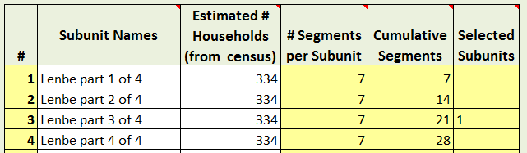

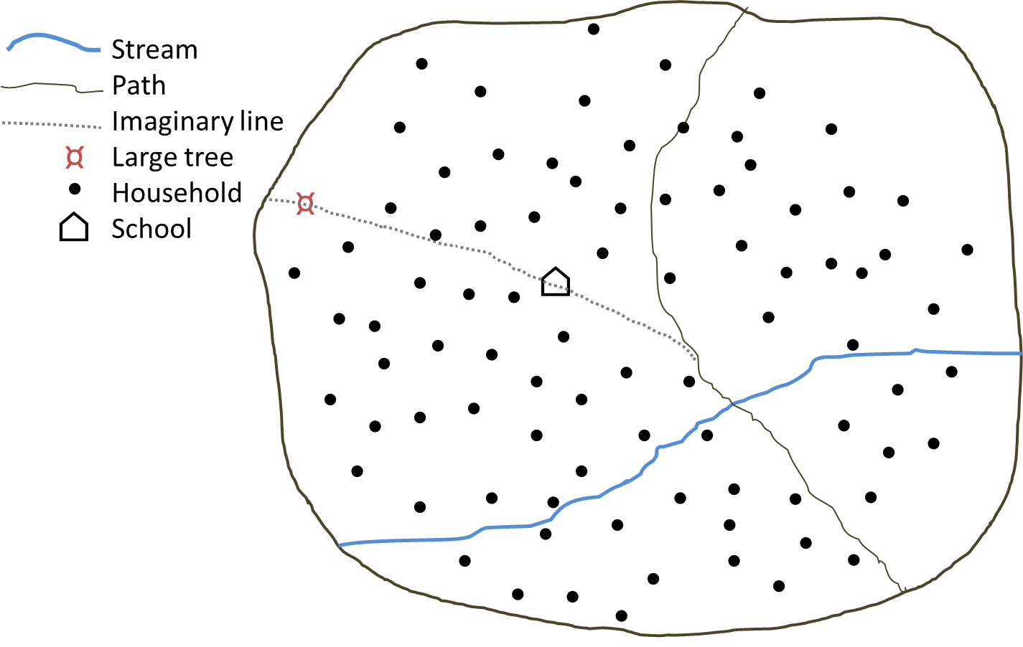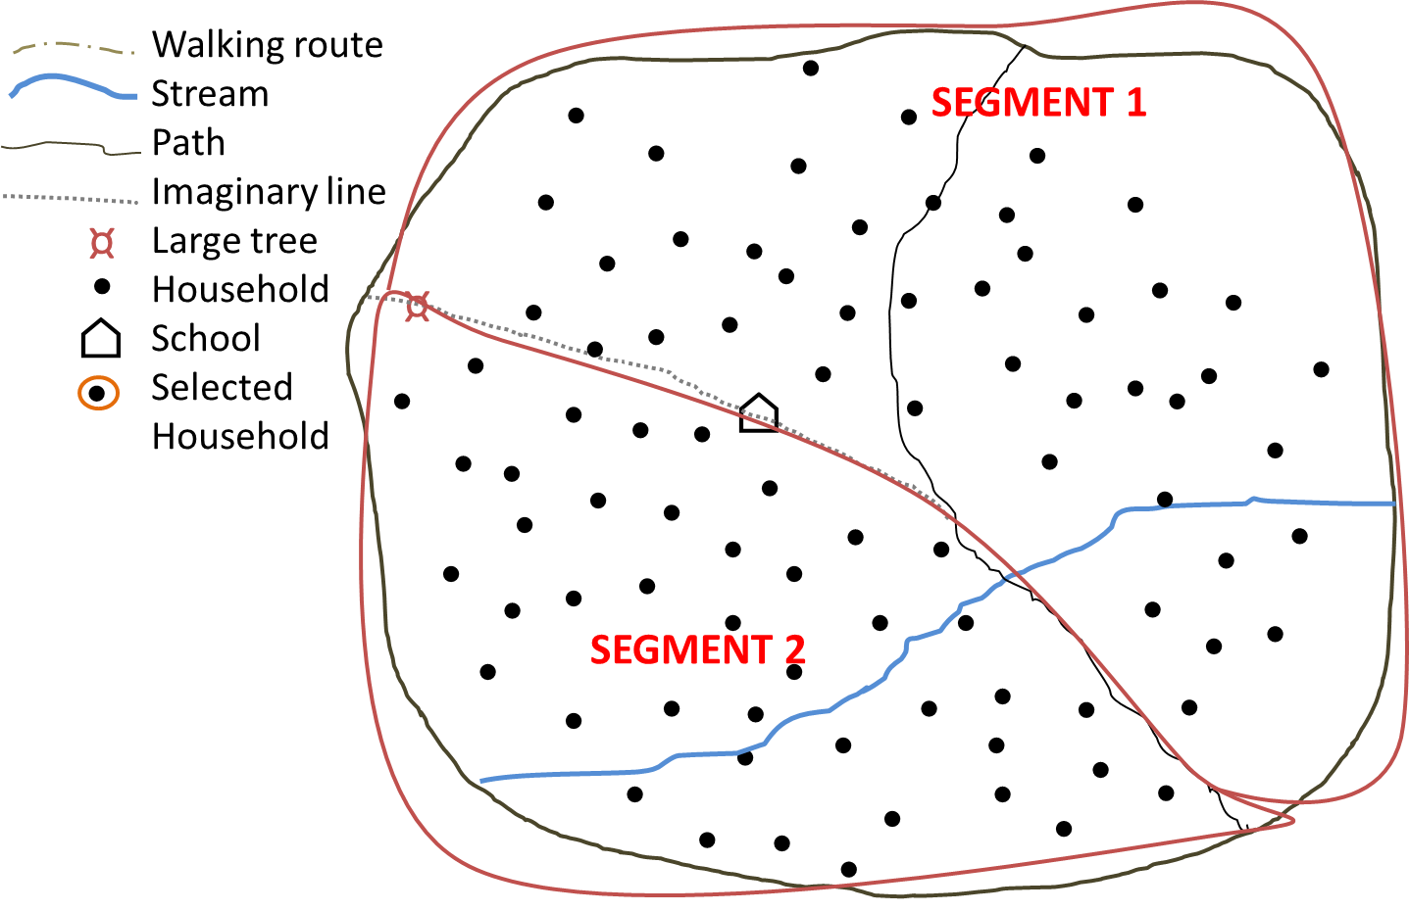

**Panel C**

**Panel D**

**Panel A**

**Panel B**

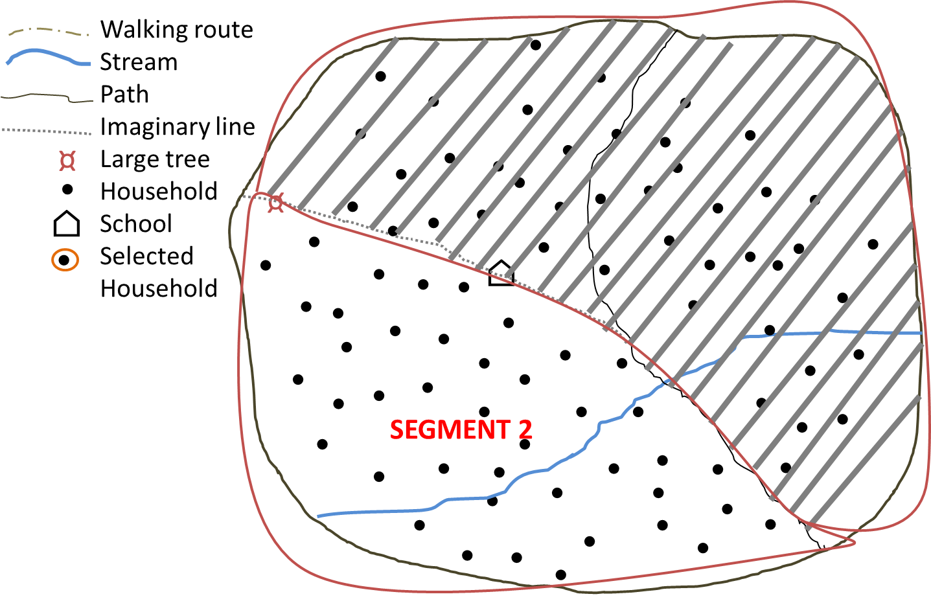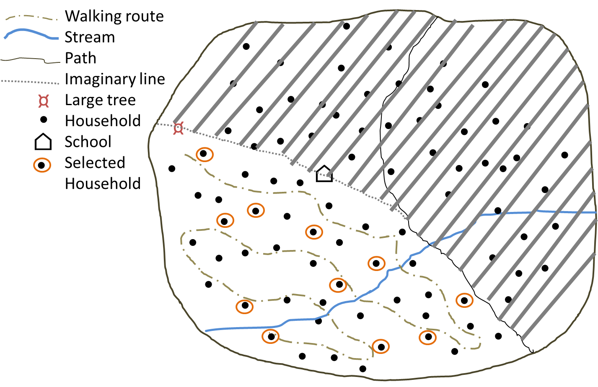

**Figure 1.** **Depiction of the steps required for creating segments and selecting households within each segment.**  Panel A) Example of a rural EA with approximately 85 households. Panel B) The EA is segmented into 2 segments of approximately equal size using natural lines of division. Panel C) One segment is randomly selected (using coin toss or drawing pieces of paper from a hat/bowl). Panel D) A walking route through the selected segment is identified that passes by all households in the segment and households are selected for the survey according to the selected sampling list (either List A or List B).

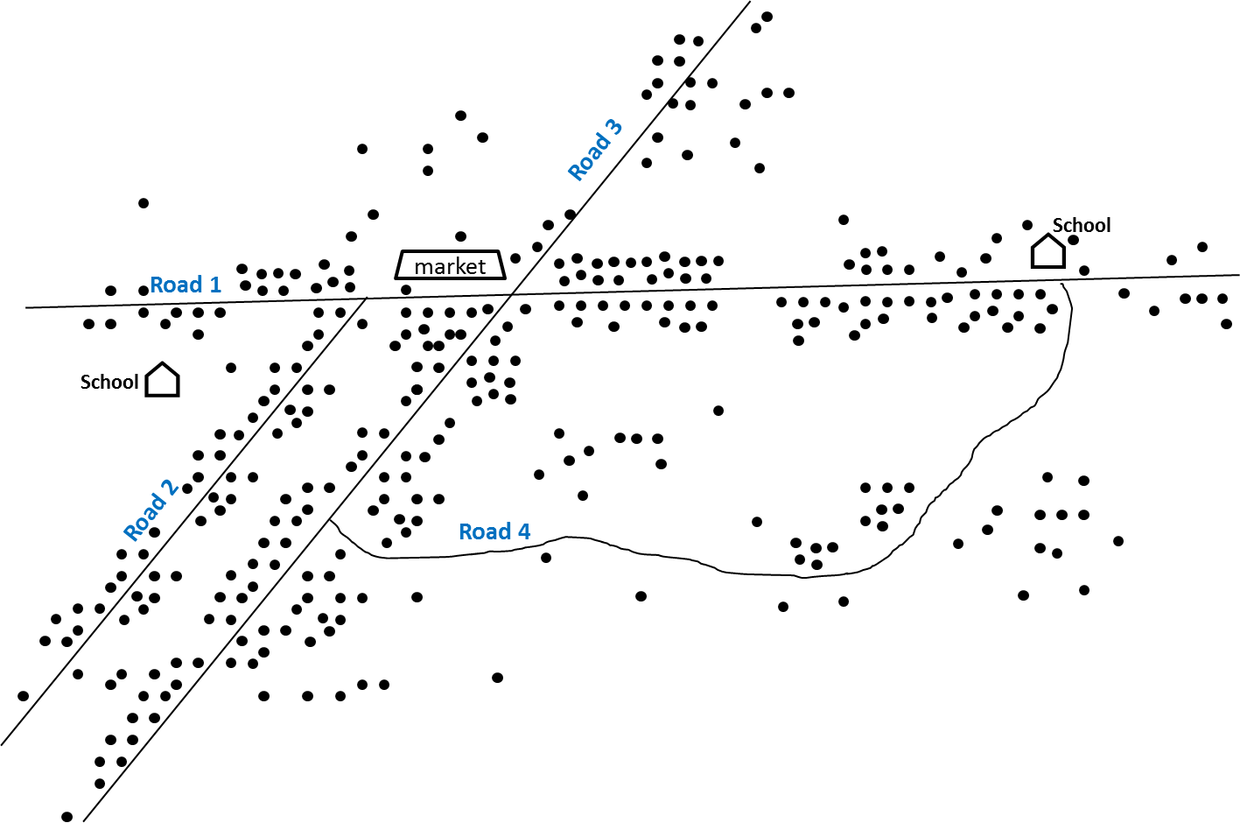

**Panel A**

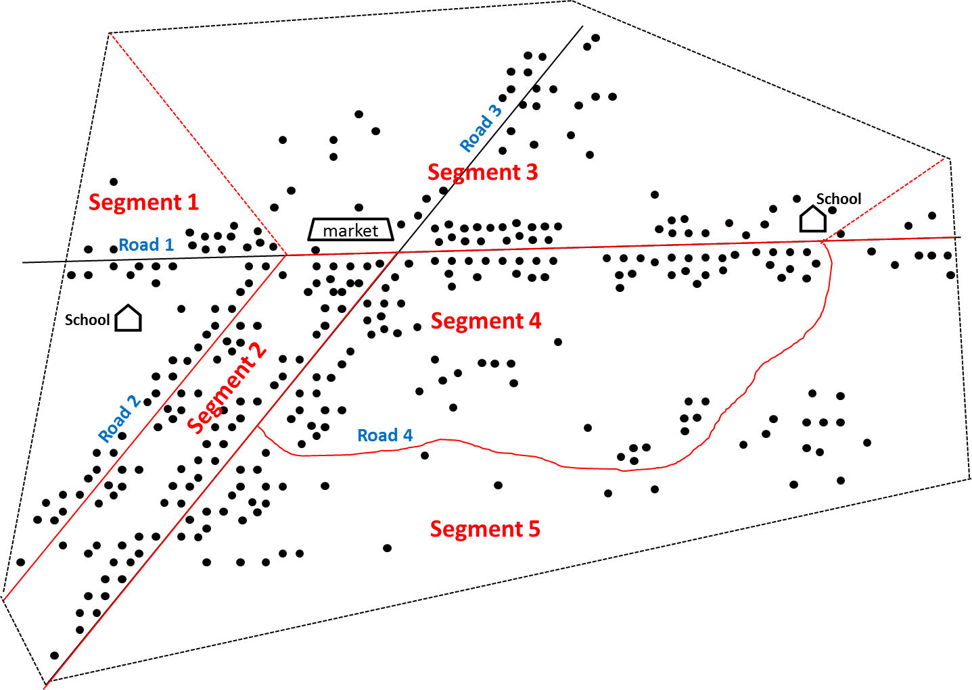

**Panel B**

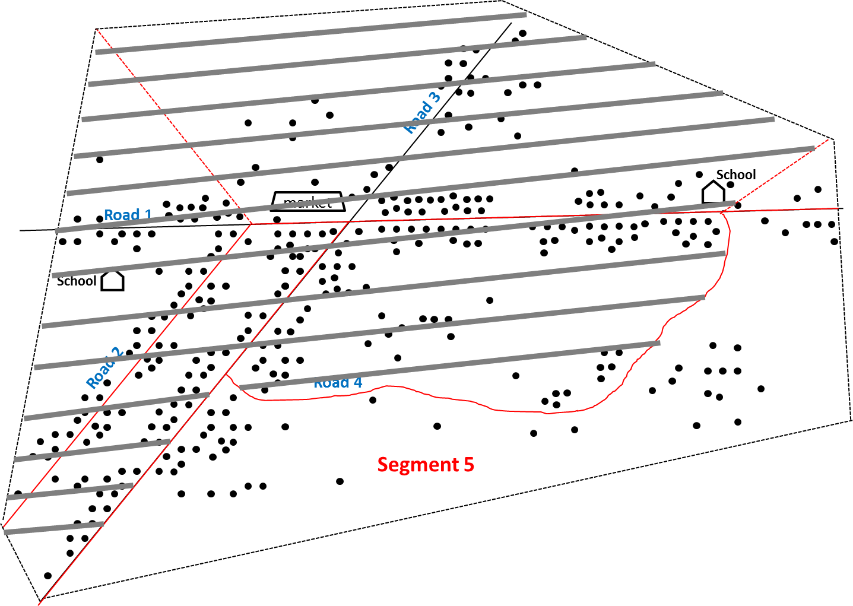

**Panel C**

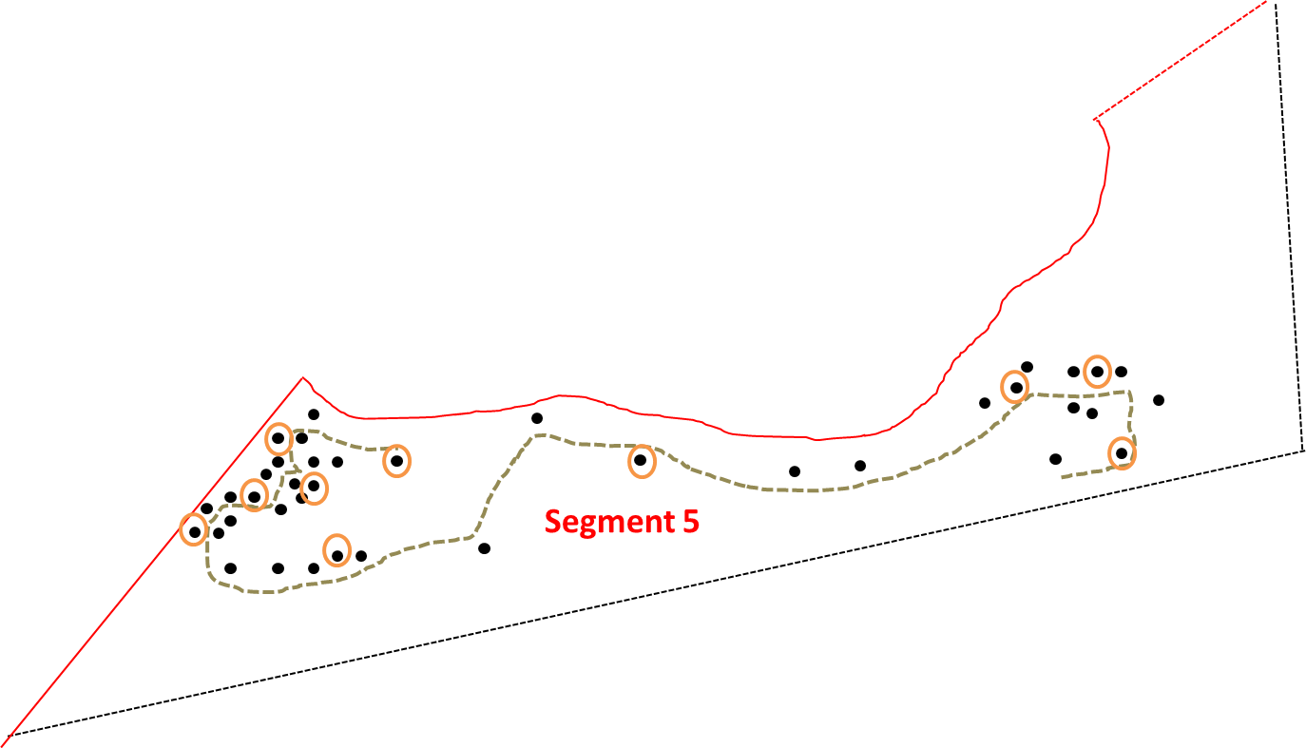

**Panel D**

**Figure 2. An example of segmentation in a larger semi-urban EA.**  Panel A) A sketch map of a semi-urban EA with ~270 households. Panel B) The EA is divided into 5 segments with approximately equal numbers of households using roads as the primary line of division between segments. Panel C) Segment 5 is randomly selected. Panel D) ) A walking route through segment 5 is identified that passes by all households in the segment and households are selected for the survey according to the selected sampling list.

COMMON QUESTIONS:

**Does each segment need to have exactly the defined number of households?**

No, it is **more important** that each segment have **approximately equal numbers of households** than it is for a segment to contain exactly the target segment size. In fact, because of rounding and errors with the population estimation, it is unlikely for any one segment to have exactly the defined number of households. For example, if the target segment size is set at 50 households, in practice in some subunits the segments may end up having closer to 40 households, while in other subunits they may have 60.

**What if the same subunit is selected more than once by the CSB?**

If a subunit is very large it may be selected more than once (see Section 5, step 5). In this case, the number of segments selected from the subunit should correspond to the number of times it was selected. Put a piece of paper into a hat or bowl for each segment in the subunit and then draw pieces of paper from the hat corresponding to the number of times the subunit was selected. The same segment may not be selected more than once.

**Example:**

Suppose that *both* the 21st and 22nd selected segments come from the same subunit, which has 390 households. As with the previous example, the first step is to divide the subunit into equal subgroups. The subunit requires 390/50 = 8 segments. Because 8 is a lot of segments, it may take some time and even require the aid of rough maps, to divide the subunit into roughly 8 equal parts. The next task is to randomly select the two segmentsfrom the eight segments which will be the 21st and 22nd selected segments. This can be done using by drawing numbers from a hat or bowl. The same segment may not be selected more than one.

**How can segmentation be used in urban areas?**

Segmenting urban areas can be easier than segmenting rural areas, as cities and towns are usually organized into blocks or some similar units. When using EAs, maps are usually available showing streets and blocks; if unavailable, these maps can be drawn. It is not recommended to use subunits other than EAs for urban areas, as they may vary considerably in size and be less likely to have maps to aid in segmentation.

## SECTION SEVEN: SELECTING HOUSEHOLDS WITHIN SELECTED SEGMENTS

**Once segments have been chosen among the sampled subunits, households will be selected within each sampled segment for inclusion in the coverage survey.** A previously established sampling interval, automatically applied by the CSB, is used to determine which households in the segment are to be sampled to reach the expected sample size. The CSB will generate two lists (Lists A & B) to facilitate the selection of households within the segment, according to the sampling interval. It is recommended that the Survey Coordinator generate these lists in advance using the CSB and give each survey team a laminated copy of Lists A & B to carry with them in the field.

The survey teams should follow the steps outlined in **Box 4** to identify the households from which individuals will be interviewed.

**Box 4: Selecting households within each segment**

**Step 1: Identify a route through the segment.** The survey team should work with a local guide to identify a walking route that will pass by every house in the segment and determine which household will serve as the initial household.

**Step 2: Select list A or B.** Flip a coin to determine if List A or list B will be used.

**Step 3: Follow the route through the segment and survey households according to the selected list.** Starting with the initial household, enumerate households as you follow the predetermined route through the segment (ignoring any structures that are not households). If culturally acceptable, it is often helpful to number the door of each household with chalk. For each enumerated household that corresponds to a number on the selected list, stop and interview ***all*** members of the survey population who were living in the household at the time of the MDA (see Section 8). Continue until the next number on the selected list is greater than the total number of households in the segment.

**Example:** Suppose the CSB generates the following Lists A and B for this coverage survey (below). In addition, suppose that the survey team has already randomly selected a single segment within the subunit (Section 6) and identified a route through the selected segment that will pass by each house (Step 1, above). At this point a team member flips a coin and selectes List A. The survey team then walks the predetermined route through the selected segment, counting each household they pass. The team does nothing except to count (or label with chalk) the 1st, 2nd, 3rd and 4th households they pass. When they arrive at the 5th household, the team stops to interview **all members** of the survey population living in the household because this is the first household number on the selected List A (the starting “0” on List A can be ignored, as there is no 0th house). Having finished all interviews in the 5th household, the team then continues counting each house along the predetermined route (e.g., 6th, 7th, 8th, …) until they arrive at the 10th household, the next on List A. Once again the team stops and interviews all members of the survey population living in the household. This process continues until the team reaches the last household in the segment; for the sake of example, suppose this corresponds with the 47th household. **At this point the team stops because they have visited each house in the segment, even though List A has additional numbers**. The sampling is considered complete for that segment and the team may travel onto the next selected subunit.

**Important note:** Lists A & B are intentionally made to be much longer than will be necessary for most segments. Since most segments are expected to have ~50 households, most survey teams will complete sampling in a given segment before they reach the end of the list. Once a segment is complete the teams should not attempt to enroll additional households in order to reach the end of List A or List B. Lists A & B are longer than necessary to account for the rare instances where the actual size of a selected segment is significantly greater than planned (e.g. has 80 households), which may be due to faulty census projections or a segmentation imbalance. In such instances it is important to have enough households in List A & B so that the team can still apply the set sampling interval to *all* households in the segment even if it results in an unusually large sample size from that one segment.

**Step 4: Sampling two survey populations (*only applies to integrated coverage evaluations)*:** If your survey has two survey populations, then Lists A & B will have additional asterisks (*) by some of the numbers. The numbers in Lists A & B correspond to the households in which survey population 1 – which should correspond to the smaller of the two survey populations (e.g. children 5-14 years) – are sampled. Numbers with an asterisk correspond to those households in which individuals from *both* survey populations should be sampled (e.g. children 5-14 and everyone living in the household).

**What if people live in compounds instead of households?**

In some settings, such as sub-Saharan Africa, households may be grouped into compounds, which are more visible and easier to enumerate than households.

**Example:**

Instead of sampling 1 in 4 *households* according the List A, the survey team could use the same List A to sample 1 in 4 *compounds* throughout the segment (assuming that segment size is still based on the number of households – such as 50 households). Within each selected compound ***all*** members of the survey population who were living there during MDA would be surveyed.

## SECTION EIGHT: SURVEYING SELECTED INDIVIDUALS

*All* household members living in the selected house or compound who are part of the survey population –the predetermined age group that is the focus of the coverage evaluation survey – should be interviewed. Information for young children (<10 years) may be collected from their primary caretakers or from the child themselves. In surveys where children were treated through schools, it may be appropriate to ask only the children directly.

**Questionnaire**

A sample questionnaire is attached as Appendix 1. This questionnaire contains the minimum information required to assess MDA coverage. It is important to ask whether people were *offered* the drugs (this provides a measure of the programme’s ability to reach the population) **and** whether they *swallowed* the drugs (this provides an estimate of the PC coverage). The survey coordinator may choose to add additional questions including: incidence of side effects; knowledge, attitudes and practices of the population; socio-economic status, NTD-related morbidity; household status of water, sanitation and hygiene; or other indicators for which a population-based statistically valid answer is desired. The questionnaire should be tested locally prior to use and back-translated from any local language to ensure consistency.

**Electronic data collection**

Electronic data collection, via handheld mobile devices, is a viable alternative to the paper-based questionnaire shown in Appendix 1. Electronic data collection often incorporates built-in error-checking, which can help to minimize data entry and tabulation errors. It is also helpful for instituting skip patterns and saving paper. A disadvantage is that it may be harder for supervisors to review questionnaires completed electronically, particularly if the data are sent to the cloud as soon as the interview is completed. When an electronic data collection system is used, it is recommended that all members of the survey team receive training on the system and that only those who demonstrate the ability to correctly enter data on the device be put in charge of actual data collection in the field. Use of an electronic data capture device does not change the recommended survey sampling methodology described above.

**Households with no members of the survey population**

If there is no member of the survey population in the selected household, or if the entire household is absent and not expected to return later in the day, proceed to the next selected household. A replacement household is not needed; the sample size was inflated to account for non-response (Section 4, step 5).

**Absent individuals**

If an adult (>10 years) survey respondent is absent but expected to return later in the same day, the survey team should make an attempt to revisit the household. If the survey respondent is not expected to return, or is absent upon the revisit, then the survey team should try to reach the individual via mobile phone. If this is not possible, another adult in the household may serve as a proxy respondent and answer on behalf of the absent individual. If a child >10 years is absent but expected to return later in the same day, the survey team should make an attempt to revisit the household, or to visit the school they attend.

**Integrated assessment**

For integrated coverage surveys with multiple survey populations, it is recommended that a *separate* form be used for each survey population. The sampler (person in charge of sampling) on the team should use the selected list (either List A or List B) to know in which households survey population 1 is interviewed (e.g. households with no asterisk) and in which households *both* survey populations 1 & 2 are interviewed (e.g. households with an asterisk). In households where both survey populations are to be interviewed, there may be some individuals who fall into both populations. These individuals will be interviewed twice, once for each drug package.

# CHAPTER 4: INTERPRETATION AND ACTION PHASE

## SECTION NINE: ANALYSIS AND INTERPRETATION OF RESULTS

Once data collection is complete, the results should be compiled to assess survey coverage. While there are many reasons for conducting a coverage evaluation, the two main objectives are: 1) **to estimate the PC survey coverage** and determine if it exceeds the target coverage threshold, and 2) **to validate the reported program (or administrative) coverage.**

Due to the use of cluster sampling, as opposed to a simple random sample of population members (which is not operationally feasible), it is not possible to calculate the confidence intervals around each estimate by hand. Instead, a data entry form and simple website have been developed to facilitate the confidence interval calculations (see Appendix 4 for more detail) .

The CSB provides the user with a “Results Entry Form” (also shown in Appendix 3). Enter the summary information for each selected segment, that is the total number of people interviewed from that segment, the number of people who reported being offered the drug and the number of people who reported swallowing the drug. The information for each segment should be entered in the order in which it was selected from the Coverage Survey Builder (aka geographic order). Complete a separate Results Entry Form for each drug assessed. *DO NOT* modify this form by adding rows or columns. It is strongly recommended that the data be entered into the “Results Entry Form” twice by two separate individuals (double data entry) and that any discrepancies between the two be addressed, in order to minimize data entry errors.

Once your information has been entered, save each Results Entry Form as a csv file (separate files should be created for each drug). This information can then be uploaded directly into the online Coverage Survey Analysis Tool at: <http://analysis.linkssystem.org>. Verify that the information has uploaded correctly into the web tool (alternatively you may enter the information directly into the web tool by hand) and click, “calculate”. The programme will then return the estimate for the **survey coverage**  and the **programme reach** along with the corresponding 95% confidence limits and design effects.

**Estimating PC Survey Coverage**

The data gathered in the survey can be used to estimate the true PC coverage. Because the survey methodology employed produces an equal probability sample, sample estimates can be calculated without the use of sample weights. The estimated coverage can be calculated as follows:

|  |  |  |
| --- | --- | --- |
| Survey coverage | = | [Number of “yes” responses to having **swallowed** the drug] |
| [Total number of people interviewed][4] |

*Interpretation:*If the survey coverage falls below the target coverage threshold (**Table 2**), it is evidence that the MDA needs improvement. If the survey coverage is well above the target coverage threshold (e.g., at least 10 percentage points greater than the threshold), then it is evidence that the MDA was successful and the programme is functioning well. When the survey coverage is near the target coverage threshold (e.g., <10 percentage points above the threshold), visual inspection alone is not sufficient to conclude that margin of error around the survey coverage it is greater than the target coverage threshold. In such instances, the **1-sided lower 95% confidence bound** of the survey coverage should be compared to the target coverage thre shold (**Table 2**) to determine if the true PC coverage is likely to have exceeded the target coverage threshold. This lower confidence bound will automatically be calculated by the Coverage Analysis Tool (at the website listed above). The survey coverage is a measure of both the reach of the programme and individual compliance with MDA. If the 1-sided lower 95% confidence bound of the survey coverage is below the target coverage threshold, the appropriate conclusion is that the target coverage threshold was not met (see Section 10 for next steps).

**Example:**

Suppose the survey coverage for Azithromycin is 82%, while the target coverage threshold for trachoma is 80%. Because the survey coverage only slightly greater than the target coverage threshold (<10 percentage points), the data are entered into the online Coverage Analysis Tool to determine the 1-sided lower confidence bound. Suppose the online tool returns a lower confidence bound of 77%. This means it is likely that the true PC coverage could be as low as 77%. Because 77% is less than the target coverage threshold (80%), the evidence suggests that the present round of MDA did not meet the target threshold for effective coverage and that future improvements to increase coverage are needed.

***Programme Reach***

By collecting information on whether or not an individual was *offered* the drug package(s), it is possible to determine how well the programme was able to reach the population. The coverage of the programme reach can be calculated as follows:

|  |  |  |
| --- | --- | --- |
| Programme Reach | = | [Number of “yes” responses to having been **offered** the drug] |
| [Total number of people interviewed]5 |

*Interpretation:* Programme reach is an indicator of the proportion of the population in the survey area that has the opportunity to participate in MDA. Low programme reach could be an indicator of supply chain difficulties, community drug distributor challenges, or inadequate social mobilization. By comparing the *survey coverage* to the *programme reach*, it is possible to isolate the rate of individual compliance with MDA.

**Validation of reported coverage**

The survey coverage is expected to be an unbiased estimate of the true PC coverage in the survey population[5]. As a result, the survey coverage can be compared with the reported coverage and if the two figures are *similar* then the reported coverage can be considered validated. If the two figures are *different* then the reported coverage is not validated. However, what constitutes “similar” vs. “different” can be subjective. A more objective way of validating the reported coverage is to calculate the **95% confidence interval** around the survey coverage, based on the survey data, and determine if the reported coverage falls within this confidence interval around the survey coverage.

**Example:**

The reported coverage is 85% and the estimated coverage based on the survey data is 71%, with a 95% confidence interval of (66%, 76%). Because the reported coverage falls outside this confidence interval, is the reported coverage has not been validated by the survey results.

*Interpretation:* Is the reported coverage similar to the survey coverage? Or, is the reported coverage contained within the 95% confidence interval around the survey coverage? If it is, then the reported coverage is said to be “validated” – meaning that the reporting system is working as desired and the reported coverage estimates can be relied on for determining if the programme is meeting the target coverage threshold. If the reported coverage is very different from the survey coverage, or alternatively, if it falls outside the 95% confidence interval around the survey coverage, then the reported coverage is *not* validated. Further investigation into the reporting system, with tools such as the Data Quality Self-Assessment, may be required to understand where the inaccuracies are likely taking place.

## SECTION TEN: CONVERTING THE RESULTS INTO PROGRAMMATIC ACTION

An integral part of a coverage survey is the development of an Action Plan (Appendix 3). The Action Plan helps programmes to convert the results of a coverage evaluation survey into concrete steps to improve coverage and reporting. The Action Plan should be developed collaboratively with the national NTD programme and Ministry of Health. The national programme may then collaborate with its partners to operationalize the Action Plan.

It is strongly recommended that a **stakeholders meeting** be convened to share the coverage survey results and discuss the programmatic actions that will be taken in response. The Action Plan should be implemented prior to or during the next round of MDA, as applicable.

**Table 3** is intended to help users in developing their own Action Plan. It lists the possible findings that can occur when the survey coverage is compared to both the target coverage threshold and the reported coverage. The table provides potential causes to investigate and corrective actions that can be taken.

Table 3 Interpreting and following up reported and survey coverage results

|  |  |  |  |  |
| --- | --- | --- | --- | --- |
| **Finding or observation** | | **Potential Causes to Investigate** | | **Corrective action** |
| 1. **Comparison of survey coverage to target coverage threshold:** To get a better estimate of coverage where there is reason to believe routine reporting is incorrect | | | | |
| Survey coverage is **below** the target coverage thresholda | Check the coverage in the different sub-populations to determine whether any particular group is being left out or has lower than average coverage (e.g., males vs. females, SAC, particular sub-districts, ethnic minorities, etc.) | | Develop and implement targeted social mobilization as required  Investigate the reasons why the sub-population(s) are not adequately covered and make the appropriate change in MDA strategy/platform to reach the sub-population(s)  Consider using Independent Monitoring or the Coverage Supervision Tool with MDA mop-up during the next round to improve coverage | |
| Check the reasons for why the eligible population was **not** **offered** the drug  Check the reasons for the eligible population not **swallowing** the drug | | Tailor corrective action according to reasons given which include strengthening:   * Drug supply chain * Social mobilization and information and education campaigns (look at reasons given by those who *did* swallow the drug) * Drug delivery platform used * Training, supervision and motivation of drug distributors * Communication on adverse events * Capacity of national and/or district level staff | |
| Survey coverage is **above** the target coverage thresholdb | Communities and drug distributors are motivated and the programme is functioning well | | Congratulate your teams. Sustain programme momentum for the next year to maintain coverage levels | |
| 1. **Comparison of survey coverage with reported coverage:** To check if the data reporting system is working well | | | | |
| Reported coverage is much **higher** than survey coveragec  (i.e., routine reporting is likely overestimating true coverage) | Drug distributors are incorrectly reporting on ingestion of the drugs | | Conduct a Data Quality Self-Assessment or Data Quality Assessmentf to diagnose where the data reporting system is breaking down  Improve the skills and motivation of drug distributors through better training and supervision; consider use of mHealth technologies  Make improvements to the tally sheets and/or registers used | |
| The total population figure (e.g., the denominator) is incorrect or outdated, or people from outside the survey area are also taking the drugs and are being included in the total treatment tallies | | Determine if more accurate population estimates or projections are available and apply a correction factor to routine coverage estimates as appropriate  Ask the drug distributors to record and report non-resident individuals ingesting the drugs separately and do not include them in the numerator for calculating PC coverage | |
| Reported coverage is much **lower** than surveycoveraged  (i.e., routine reporting is likely underestimating true coverage) | The total population figure (e.g., the denominator) is incorrect or outdated | | *Refer to corrective actions given for the same problem above* | |
| Data are not being correctly aggregated or reported | | Conduct a Data Quality Self-Assessment or Data Quality Assessmentf to diagnose where the data reporting system is breaking down | |
| Reported coverage and survey coverage are **similare** | A good reporting system is in place | | Congratulate your teams. Continue using the current reporting system, with increased confidence that it provides a good estimate of PC coverage. Less expenditure in future surveys (at least for the current survey area) is required. | |
| 1. **Comparison of survey coverage with programme reach:** To assess compliance and the success of the programs social mobilization and communication strategy | | | | |
| Survey coverage is **less** than programme reach | | Check the reasons given for why individuals who were offered the drug did not swallow it | | Improved information and education campaigns may be needed prior to the next round to increase compliance |
| Survey coverage is **greater** than programme reach | | There may be a problem with the coverage survey data. Check to see if the survey team implemented the questionnaire correctly; recount results and check for arithmetic errors | | Greater training may be needed to make sure the survey team correctly understands the difference between being *offered* the drug(s) and *swallowing* the drugs and that this difference is conveyed correctly to the respondents |
| Survey coverage is close to or **equal** to programme reach | | Compliance is high | | Congratulate the teams. Continue with the current information and education campaigns, as they appear to be working |

aApplies to situations in which either the survey coverage is *below* the target coverage threshold or the 1-sided lower 95% confidence bound of the survey coverage is below the threshold.

bApplies when the survey coverage, and the 1-sided lower 95% confidence bound of the survey coverage, both exceed the target coverage threshold.

cA more objective approach is to see if reported coverage is *greater than* the 2-sided upper 95% confidence limit of the survey coverage.

dA more objective approach is to see if reported coverage is *less than* the 2-sided lower 95% confidence limit of the survey coverage.

eA more objective approach is to see if reported coverage is *contained within* the 95% confidence interval around the survey coverage.

fThe DQA tool is available at: http://pdf.usaid.gov/pdf_docs/PA00JZS3.pdf

# REFERENCES

Agresti, A., & Coull, B. a. (2012). Estimation of Binomial Proportions. *The American Statistician*, *52*(2), 119–126. http://doi.org/10.1080/00031305.1998.10480550

Dean, N., & Pagano, M. (2015). Evaluating confidence interval methods for binomial proportions in clustered surveys. *Journal of Survey Statistics and Methodology*, *3*, 484–503.

Grais, R. F., Rose, A. M., Guthmann, J.-P., Levy, P., Lemeshow, S., Henderson, R., … Fleiss, J. (2007). Don’t spin the pen: two alternative methods for second-stage sampling in urban cluster surveys. *Emerging Themes in Epidemiology*, *4*(1), 8. http://doi.org/10.1186/1742-7622-4-8

Laplace, P.-S. (1812). *Théorie analytique des probabilités*.

Rust, K. F., & Rao, J. (1996). Variance estimation techniques for complex surveys using replication techniques. *Statistical Methods in Medical Research*, *5*, 283–310.

Turner, a G., Magnani, R. J., & Shuaib, M. (1996). A not quite as quick but much cleaner alternative to the Expanded Programme on Immunization (EPI) Cluster Survey design. *International Journal of Epidemiology*, *25*(1), 198–203. http://doi.org/10.1093/ije/25.1.198

UNICEF. (n.d.). Multiple Indicator Cluster Surveys. Retrieved November 3, 2016, from http://mics.unicef.org/tools

World Health Organization. (2011). Monitoring and epidemiological assessment of mass drug administration in the global programme to eliminate lymphatic filariasis: a manual for national elimination programmes, *WHO/HTM/NT*. Retrieved from http://www.who.int/lymphatic_filariasis/resources/9789241501484/en/

World Health Organization. (2015). World Health Organization Vaccination Coverage Cluster Surveys: Reference Manual. Retrieved October 31, 2016, from http://www.who.int/immunization/monitoring_surveillance/Vaccination_coverage_cluster_survey_with_annexes.pdf?ua=1

World Health Organization. (2016). *Report of the WHO Strategic and Technical Advisory Group for Neglected Tropical Diseases, April 12-13, 2016*. Retrieved from http://www.who.int/neglected_diseases/NTD_STAG_report_2016.pdf?ua=1

# APPENDIX 1: HOUSEHOLD SURVEY QUESTIONNAIRE

Before using this questionnaire, it is necessary to replace ***[Drug]*** with the names of the drug(s) being assessed and to complete the survey form title with the appropriate information. If more than two drugs are being assessed by the same survey, two questionnaires will be required per household to accommodate the number of drugs. It is also important to fill in the survey population to remind the survey team which individuals should be included in the survey. The survey team should also circle the type of subunit used (e.g., EA, village or other).

If the drug(s) were distributed through a school-based MDA then it is recommended that you include question 1 about school attendance, question 2 is optional:

1. Have you attended school in the last school year [enter reference dates(months)]? (Yes/No)
2. What type of school do you attend?

* Primary (public or private)
* Secondary (public or private)
* Religious school

The survey team should bring examples of each drug to show the participants at the time of questioning to help with recall. For integrated coverage surveys with multiple survey populations it is recommended that a separate form be used for each survey population. If only one drug is being assessed, it is possible to delete the excess columns in this questionnaire. The survey coordinator may choose to add more questions to better understand factors such as: the incidence of side effects; knowledge, attitudes and practices of the population; status of water, sanitation and hygiene at the household.

If a survey respondent is absent and not expected to return, an attempt should be made to reach the adult via cellphone. If this is not possible an adult in the household may serve as a proxy respondent and answer on behalf of the absent individual. In this event, the name, age, and sex of the *absent* individual should be recorded in the questionnaire and the response to the question “Participant Present?” should be “No”. In all other cases, when the respondent is present at the time of interview, the response to this same question should be “Yes”.

Finally, this questionnaire is an example that can be edited and modified to fit the goals of the coverage survey. The reasons given for not receiving or swallowing the drugs should be modified to fit the local context. The final questionnaire should be tested locally prior to its use. A Microsoft Word version of this questionnaire is available at: http://www.ntdsupport.org/resources/coverage-survey-household-questionnaire.

**Household Survey to Measure Coverage of [*list drug(s) here*] Among [*list survey population here* ]**

Interviewer Code: |__|__|__| District: |__________________| Sub-district: |_______________|

Subunit (EA/Village/Other_______________): |___________________________| HH No: |__|__|__|

Date of interview (dd/mm/yyyy): |__|__|/|__|__|/|__|__|__|__| Household Head:_______________________________

Survey population: ________________________________________________

|  |  |  |  |  |  |  |  |  |  |  |  |  |  |  |
| --- | --- | --- | --- | --- | --- | --- | --- | --- | --- | --- | --- | --- | --- | --- |
|  | | | | | ***[Drug 1]*** | | | | | ***[Drug 2]*** | | | | |
| # | First Name | Sex (M/F) | Age  (Years) | HH member present (Y/N) | Offered the drug(s)? (Y/N/DK) | Reason not offereda | Swallow the drug(s)? (Y/N/DK) | Reason DID NOT swallowb | Reason DID swallowc | Offered the drug(s)? (Y/N/DK) | Reason not offereda | Swallow the drug(s)? (Y/N/DK) | Reason DID NOT swallowb | Reason DID swallowc |
| 1 |  |  |  |  |  |  |  |  |  |  |  |  |  |  |
| 2 |  |  |  |  |  |  |  |  |  |  |  |  |  |  |
| 3 |  |  |  |  |  |  |  |  |  |  |  |  |  |  |
| 4 |  |  |  |  |  |  |  |  |  |  |  |  |  |  |
| 5 |  |  |  |  |  |  |  |  |  |  |  |  |  |  |
| 6 |  |  |  |  |  |  |  |  |  |  |  |  |  |  |
| 7 |  |  |  |  |  |  |  |  |  |  |  |  |  |  |
| 8 |  |  |  |  |  |  |  |  |  |  |  |  |  |  |
| 9 |  |  |  |  |  |  |  |  |  |  |  |  |  |  |
| 10 |  |  |  |  |  |  |  |  |  |  |  |  |  |  |

|  |  |  |  |  |  |  |
| --- | --- | --- | --- | --- | --- | --- |
| aReason treatment was not offered | | | | bReason treatment *was not* swallowed | | cReason treatment *was* swallowed |
| 1= | Underage | 6= | Didn't hear about MDA | 1= | Fear of side effects | 1= Fear of disease(s) |
| 2= | Pregnant | 7= | Drug ran out | 2= | Bad taste | 2=To treat disease(s) |
| 3= | Breast feeding | 8= | Nobody came | 3= | Not sick | 3= Because it was given/ free |
| 4= | Sick | 9= | Other | 4= | Not enough information given | 4=Useful information from CDD |
| 5= | Absent |  |  | 5= | Other | 5=Other |

Y=”Yes”, N=”No”, DK = “Don’t Know”

# APPENDIX 2: RESULTS ENTRY FORM

|  |  |  |  |  |  |  |  |  |  |  |  |  |  |
| --- | --- | --- | --- | --- | --- | --- | --- | --- | --- | --- | --- | --- | --- |
| **Drug:** | |  |  | |  | |  | |  | |  |  | |
| **Selection Order** | **Subunit Name** | **No. Females Interviewed** | | **No. Males Interviewed** | | **No. Females Offered** | | **No. Males Offered** | | **No. Females Swallowed** | | | **No. Males Swallowed** |
|  |  |  | |  | |  | |  | |  | | |  |
|  |  |  | |  | |  | |  | |  | | |  |
|  |  |  | |  | |  | |  | |  | | |  |
|  |  |  | |  | |  | |  | |  | | |  |
|  |  |  | |  | |  | |  | |  | | |  |
|  |  |  | |  | |  | |  | |  | | |  |
|  |  |  | |  | |  | |  | |  | | |  |
|  |  |  | |  | |  | |  | |  | | |  |
|  |  |  | |  | |  | |  | |  | | |  |
|  |  |  | |  | |  | |  | |  | | |  |
|  |  |  | |  | |  | |  | |  | | |  |
|  |  |  | |  | |  | |  | |  | | |  |
|  |  |  | |  | |  | |  | |  | | |  |
|  |  |  | |  | |  | |  | |  | | |  |
|  |  |  | |  | |  | |  | |  | | |  |
|  |  |  | |  | |  | |  | |  | | |  |
|  |  |  | |  | |  | |  | |  | | |  |
|  |  |  | |  | |  | |  | |  | | |  |
|  |  |  | |  | |  | |  | |  | | |  |
|  |  |  | |  | |  | |  | |  | | |  |
|  |  |  | |  | |  | |  | |  | | |  |
|  |  |  | |  | |  | |  | |  | | |  |
|  |  |  | |  | |  | |  | |  | | |  |
|  |  |  | |  | |  | |  | |  | | |  |
|  |  |  | |  | |  | |  | |  | | |  |
|  |  |  | |  | |  | |  | |  | | |  |
|  |  |  | |  | |  | |  | |  | | |  |
|  |  |  | |  | |  | |  | |  | | |  |
|  |  |  | |  | |  | |  | |  | | |  |
|  |  |  | |  | |  | |  | |  | | |  |
|  | **Total Sample Size** | **0** | | **Female Sample Size** | | **0** | | **Male Sample Size** | | **0** | | |  |
|  | **Program Reach** | **0** | | **Female Program Reach** | | **0** | | **Male Program Reach** | | **0** | | |  |
|  | **Surveyed Coverage** | **0** | | **Female Surveyed Coverage** | | **0** | | **Male Surveyed Coverage** | | **0** | | |  |

# APPENDIX 3: COVERAGE EVALUATION ACTION PLAN

|  |  |  |  |  |
| --- | --- | --- | --- | --- |
| **Problem/Weakness Identified** | **Action Required**  (what tasks do you need to do to address the problem) | **Success Criteria**  (how will you identify your success) | **Time Frame**  (by when do you need to complete the tasks) | **Resources**  (who or what can help you complete the tasks) |
|  |  |  |  |  |
|  |  |  |  |  |
|  |  |  |  |  |
|  |  |  |  |  |

# APPENDIX 4: STATISTICAL FORMULAS AND RATIONALE

The coverage survey methodology described in this guide is derived from the “modified segment design” option described in the manuals for UNICEF’s Multiple-Indicator Cluster Surveys 2-4 (UNICEF, n.d.) and by Turner et al. (Turner et al., 1996).  In the UNICEF “modified segment design,” subunits (enumeration areas) are chosen with probability proportional to estimated size (where size is expressed as number of segments), using 20-30 households as the segment-size range.  In the field, the subunits selected for the survey sample are divided into this predetermined number of segments, such that the segments are of approximately the same size in households.  Then, one segment is selected at random and all households and eligible household members in the segment are included in the survey sample.  Thus, it is a compact-segment design.

This coverage evaluation survey design is the same except that it is does not use compact segments.  The desired segment size is set at 50 households and if fewer than 50 households per segment are needed on average to obtain the desired survey sample size (as would usually be the case), a fixed proportion of households is selected systematically from among the households in segments selected for the survey sample.  Although this change introduces the extra step of sampling households within segments rather than selecting all of them, it has the advantage of reducing the time needed for segmentation since subunits do not need to be divided into so many segments.  In addition, it may lead to some reduction of homogeneity within clusters to the extent that homogeneity increases with increasing proximity of sample households. Both the “modified segment design” and the coverage evaluation survey produce equal probability samples of the survey population.

**Formula for equal probability sample**

The formula below demonstrates how the sampling strategy used by this method results in an equal probability sample.

Definition of terms:

*f* = sampling fraction (may refer to households or compounds); the same value is used for all selected segments (e.g., 25% or 0.25)

*householdsi =* the estimated number of households in subunit *i*

*m* = number of selected segments (aka clusters)

*P*(*HHijk*) = the probability that household *k*, in segment *j*, in subunit *i* is selected

segmentsi = the estimated number of segments in subunit *i*

$$P\left({HH}_{ijk}\right)=m\left(\frac{segments_{i}^{}}{\sum{segments_{i}^{}}}\right)\left(\frac{1}{segments_{i}^{}}\right)\left(f\right)$$

$$P\left({HH}_{ijk}\right)=\left(\frac{m}{\sum{segments_{i}^{}}}\right)\left(f\right)$$

Where ${segments}_{i}^{}=round to nearest integer\left(\frac{{households}_{i}^{}}{target number households per segment}\right)$

Note: ${households}_{i}^{}$ always ≥ $\left(\frac{target number households per segment}{2}\right)$ so ${segments}_{i}^{}$ always ≥1; any subunit with an expected number of households that is less than half the target number of households per segment should be combined with the next subunit on the sampling frame that is in close geographic proximity (Section 5, Box 2, Step 3).

**Approach for determining the target segment size**

This number is the number of households that should be included, on average, in each segment. The target segment size is automatically calculated by the CSB but can be calculated manually as follows:

$$Target Segment Size=max⁡\left[\frac{(Sample Size)}{30*(Expected \# people in survey pop. per HH)},50\right]$$

where:

$$max\left[1,…,n\right]{= maximum of elements [1, …,n]}$$

The ‘expected number of people in the survey population per household’ used above is the same figure that was calculated in Section 3. If the sample size divided by the product of the expected number of people in the survey population per household and the number of clusters (e.g., 30), is greater than 50, then this larger number will be the target sample size and each segment should contain, on average, this many households. Otherwise, when this figure is <50, the target sample size will be equal to 50 households.

In the event of an integrated coverage survey with two survey populations, the survey population with the *fewest* expected number of people per household should be used in the equation above to calculate the target segment size. This will ensure that each segment has sufficient households to collect the samples size required for both survey populations.

**Sample Size and Confidence Interval Calculation**

The sample size calculations used in this manual assume a sufficiently large *n* in order for estimated proportions to be well approximated by the normal distribution (for district level estimates this will always be true). Using the Wald method for the binomial distribution (Laplace, 1812) this sample size takes the form:

$$=\frac{ ({Z^{2}}_{1-∝/2})(p)(1-p)}{δ^{2}}*\frac{DEFF}{(1-r)}$$

The first term in this equation is the standard Wald sample size formula, where *p* is the expected proportion of coverage, δ is the desired precision and Z1-α/2 is the z-score from the normal distirbution corresponding to a confidence interval of width +δ. The second term is added to include the design effect (DEFF), which accounts for the degree to which respondents in the same subunit are likely to have similar responses to the questions of coverage, and inflation of the sample size to account for the expected non-response rate (*r*). The design effect is used, rather than the average sample size per cluster and the intraclass correlation coefficient, because design effects are more commonly reported in publications of NTD coverage surveys and this historical information can be used to make appropriate DEFF estimates when planning coverage surveys.

When the expected coverage is close to 50% this Wald approach will perform well, meaning that the resulting confidence intervals around the survey coverage will have the desired width, assuming the estimated design effect was also accurate. However as the expected coverage approaches the extremes (e.g., 0% or 100%) the resulting confidence intervals around the survey coverage may not have the desired width and the confidence interval may, upon repetition, be less likely to contain the true population parameter (Agresti & Coull, 2012; Dean & Pagano, 2015). Because the expected level of coverage used to calculate the sample size is likely to be close to 50% for NTD coverage surveys (this manual recommends 50% be the default, with values not to exceed 85%) the Wald method is considered, by authors of this field guide, to be an acceptable approach for NTD coverage survey sample size calculation. An added advantage of the Wald approach is that it is widely used and the calculations can be performed in the absence of statistical software.

Once the coverage survey data have been collected, the online coverage survey analysis tool (<http://analysis.linkssystem.org>) can be used to calculate 95% confidence limits of the coverage estimate. The online tool will return two different confidence limits: the lower 1-sided 95% confidence bound, which is used to determine if the target coverage threshold is likely to have been met; and the 2-sided 95% confidence limits around the coverage estimate, which can be used to validate the reported coverage. Because the survey coverage may take on values that are close to 0 or close to 1, the logit method (Rust & Rao, 1996), rather than the common Wald method, is used to calculate the 95% confidence limits, as the logit calculation a) never returns limits that fall outside the 0-100% range and is more likely to contain the true population coverage value (1-α)% of the time than the Wald interval for extreme proportions (Dean & Pagano, 2015).

# APPENDIX 5: INTERVIEWING TECHNIQUES

In order for the coverage evaluation survey to provide helpful information to country programs, it is important that the data be as accurate as possible. The quality of data collected by the survey team can be greatly affected by the interviewer. Information contained in this section is intended to minimize data errors caused by interviewer.

1. Building Rapport

* Introduce yourself and the purpose of your visit. If you have a village leader or health volunteer acting as a community guide it may be recommendable for him/her to introduce the team.
* Take into consideration your target respondents and make efforts to connect with them. You need to dress appropriately and conduct yourself in a manner that will not cause discomfort or embarrassment.
* Give the respondent an opportunity to ask questions he/she may have before you start the interview.
* Seek the respondent’s consent before starting the interview.
* People who were directly involved in the distribution of drugs within the subunit (e.g. community health volunteers, auxiliary nurses, teachers) should not accompany the survey team to the household interviews, as their presence may influence the responses given.

1. Conducting Interviews

* Do not suggest answers to the respondents.
* Spend time describing the MDA using as much local context as possible. For example: describe what the distributers were wearing, list any additional items the distributers were carrying or distributing (e.g., bednets, dosing poles), give the time of year that the MDA took place and any other details that may help respondents to accurately recall receipt of MDA.
* Show each respondent an example of the medication. It is often helpful to let the respondent hold the medication in their hand to help jog memory.
* Speak slowly and clearly.

1. Ending the Interview

* Thank the respondent.
* Ask the respondent if he/she has any questions.

# APPENDIX 6: EXAMPLE OF A COVERAGE QUESTIONNAIRE WITH KNOWLEDGE ATTITUDES AND PRACTICES QUESTIONS ADDED

**Consent Script**

‘‘Hello, my name is <name>. I am here on behalf of the Ministry of Health. We are surveying houses in your community about the most recent community drug distribution. We would like to know if the members of your house took the drugs. If you wish to participate in the survey, tell us and we will note your answer. If you agree, the survey will only take a few minutes. Taking part in the house survey will not benefit you directly, but the results will help the Ministry of Health improve the program. It is your choice to take part, or not to take part, in this survey. You may refuse without penalty. Would you like to take part in our survey? ’’

Yes No

*[if No, skip to END and record the refusal]*

**Personal Section**

Q1. First name: _________

Q2. Sex (M/F) __________

Q3. Age (years)__________ *Note: approximate age if unknown*

Q4. Were you in the community between **Time** and **Time**?

No = 0 Yes =1 Unsure = 2

Q5. How long have you lived in this community?

*___ years ____ months*

*[If not living here at time of MDA, skip to END]*

Q6. Is the respondent answering for himself/herself?

No = 0 Yes =1

*[Enumerator should answer without asking respondent]*

*Q7.* What is the highest level of education that you have *completed*?

1=No formal education

2=Primary school

3=Lower Secondary school

4=Upper secondary school or vocational training

5=University

6=Graduate/Post graduate

Q8. *[For school-aged children respondents only]* How often do you attend school?

0 = Rarely attends or not enrolled

1 = Occasionally attends

2 = Frequently attends

3 = Always or almost always attends

**Main Section**

Q9. Did someone give you **DRUG B** and **DRUG A** between **Time** and **Time** to treat **Disease X** or **Disease Y**? *[Show the pills to the respondent]:*

**DRUG A** No = 0 Yes =1

**DRUG B** No = 0 Yes =1

*[If any Yes, skip to Q11]*

Q10. Why didn’t you receive the drugs?

0=unaware of MDA

1=distributor did not come to my house/school/fixed point location

2=drugs finished

3=pregnant

4=breastfeeding

5=ill

6=old

7=underage

1=afraid of side effects

2=I am not at risk for this disease

5=I am taking other medications

6=medicine doesn’t work

12 = I was busy

13 = I was too far away

14=other (specify) ______________

*[Skip to Q18 below]*

Q11. Did you swallow the **DRUG A** and **DRUG B**?

*[Show the pills to the respondent]:*

**DRUG A** No = 0 Yes =1

**DRUG B** No = 0 Yes =1

*[If Yes to all, Skip to Q13]*

Q12. Why didn’t you swallow the pill(s)?

0=unaware of MDA

1=distributor did not come to my house/school/fixed point location

2=drugs finished

3=pregnant

4=breastfeeding

5=ill

6=old

7=underage

1=afraid of side effects

2=I am not at risk for this disease

5=I am taking other medications

6=medicine doesn’t work

12 = I was busy

13 = I was too far away

14=other (specify) ______________

*[Skip to Q15]*

Q13. Why did you swallow the drugs?

1=to be healthy

2=afraid of getting the disease

3=someone told me to

4=everyone else is taking it

5=other (specify) ______________

Q14. Did you swallow these drugs in front of the person who gave them to you?

No = 0 Yes =1 Unsure = 2

Q15. Who gave you the drugs?

1=family member

2=health staff

3=drug distributor

4=community leader

5=teacher

7=other (specify) ______________

99=not applicable

Q16. Did you feel any side effects after swallowing the drugs?

No = 0 Yes =1 Unsure = 2

*[If No, skip to Q18 below]*

Q17. Which of the following statements are true about side effects you experienced after swallowing the drugs:

1=mild (did not interfere with daily activities)

2=moderate (interfered with daily activities)

3=serious (required hospitalization)

Q18. Were you aware of the MDA before it happened?

No = 0 Yes =1 Unsure = 2

*[If No, skip to Q20]*

Q19. How did you know the MDA was going to happen? *[Prompt: anywhere else?]*

*[Select all that apply]*

1=family member / friend / neighbor

2=professional health staff

3= community drug distributor / community health worker/ teacher

4= community or religious leader

5= brochures/flyers

6=posters

7=banners

8=radio

9=TV

10= social media

11=unaware of MDA

12= other (specify) ______________

Q20. Did any of your neighbors take the drugs from the MDA?

No = 0 Yes =1 Unsure = 2

**Thank you for your time**

*Note: The following questions are recommended for addition if there is a need to collect information on an estimate of the number of lymphedema and hydrocele patients in the coverage survey area. Questions 21 and 22 should be used in conjunction with visual aids in order to estimate the prevalence and number of lymphedema and hydrocele cases in the evaluation unit:*

Q21. Have you had <insert local word for lymphedema> for the last three months?  *[Show photo of lymphedema from job aid]*

No = 0 Yes =1 Unsure = 2 Refuse to answer = 3

Q22. Do you have <insert local word for hydrocele>?  *[Show photo of hydrocele from job aid]*

No = 0 Yes =1 Unsure = 2 Refuse to answer = 3

-------------------------------------------------------------------------------------------------------------------

*Notes for adapting questionnaire to country context (Delete from final copy)*

* Replace **bold words** with relevant drug types and MDA details
* Add additional lines to **Q9** and **Q11** if more drug packages are needed
* Insert local phrases into the script or hints to reference concepts (e.g. “after rainy season”, “before the election”) if local phrases better reference the concept
* Review answer options to ensure they include relevant choices for survey context

1. WHO (2012). Accelerating work to overcome the global impact of neglected tropical diseases: a roadmap for implementation. Accessible at http://www.who.int/neglected_diseases/NTD_RoadMap_2012_Fullversion.pdf
2. Murray CJ, Shengelia B, Gupta N, et al. Validity of reported vaccination coverage in 45 countries. Lancet. 2003;362(9389):1022–1027.
3. Maps (also referred to as “sketch maps”) are typically available from the same governmental office that conducts the national census. Both the Demographic Health Survey and UNICEF’s Multiple Indicator Cluster Survey routinely use EAs as the primary sampling unit.
4. Individuals who responded with “don’t know” or “don’t remember” to the question: “did you swallow the drug” should be included in the denominator but not in the numerator.
5. Assuming that any errors in respondents’ ability to correctly recall whether or not they swallowed the drug are independent of true coverage.